1. **Introduction**
   1. **Purpose**

This document is created as the introduction for project WeTeach – our Capstone Project at FPT University.

* 1. **Scope**

WeTeach is an education website for all ages. Our goal is *leaners* (The one who look for courses) find a best course that have high quality content, reasonable price and the most inportant is suitable for them; and through our website, *trainer* and *leaner* can introduce their course to everyone who need it.

Our website will provide *trainer* analytics about number of course view from leaners, geography... to help them increase their courses’ quality.

The interface of the website must be simple and easy to use. The website must have the interface as well as logical layout, attractive design. Moreover, the website must also have an interesting and diversity content to attract more user.

WeTeach use interface language is English because we want to attract not only Vietnamese learners and trainers but also expats especially those who looking for teaching opportunity.

1. **Overview**
   1. **Overview Description**
      1. **System Overview**

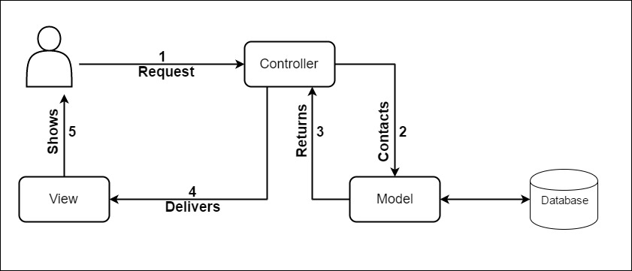

*Figure 3.1: System Overview*

* + 1. **Entity-Relationship Model**
       1. **Entity-Relationship Model**
       2. **Entity Details**
    2. **Product Feature**

|  |  |  |  |
| --- | --- | --- | --- |
| **Use Case No.** | **Function Name** | **Actor** | **Description** |
| UC01 | Sign Up as Trainer | Gs | Create new trainer account. |
| UC02 | Sign Up as Learner | Gs | Create new learner account. |
| UC03 | Sign In | Ad, Tr, Lr | Login in to WeTeach’s system. |
| UC04 | Log Out | Ad, Tr, Lr | Log out of WeTeach’s system. |
| UC05 | Change Password | Ad, Tr, Lr | This allows users to change their password. |
| UC06 | Forget Password | Ad, Tr, Lr | This allows users to reset password every time they forget. |
| UC07 | Update Profile Picture | Ad, Tr, Lr | This allows users to change their profile picture. |
| UC08 | View Personal Profile | Ad, Tr, Lr | This allows users to see their personal detail. |
| UC09 | Send Messages | Ad, Tr, Lr | This allows users to send messages to others. |
| UC10 | View Messages | Ad, Tr, Lr | This allows users to view their messages. |
| UC11 | Delete Message | Ad, Tr, Lr | This allows users to delete messages. |
| UC12 | Comment Course | Ad, Tr, Lr | Users can comment under each course. |
| UC13 | Edit Comment | Ad, Tr, Lr | Users can edit their comment. |
| UC14 | Delete Comment | Ad, Tr, Lr | Users can delete their comment. |
| UC15 | Rate Course | Ad, Tr, Lr | This allows users to rate courses. |
| UC16 | Rate Trainer | Ad, Tr, Lr | Users can rate trainers. |
| UC17 | View Course Statistic | Ad, Tr | Trainers can view their course statistic. |
| UC18 | Create New Course | Ad, Tr | This allows trainers to create new course. |
| UC19 | Edit Course Detail | Ad, Tr | This allows trainers to edit course detail. |
| UC20 | Delete Courses | Ad, Tr | Trainers can delete their course. |
| UC21 | Upload Documents | Ad, Tr | Trainers can upload document such as certification… |
| UC22 | Delete Documents | Ad, Tr | Trainers can delete their document. |
| UC23 | View Documents Dashboard | Ad, Tr | This allows trainers to access their document dashboard. |
| UC24 | Edit Profile Trainer | Ad, Tr | This allows trainers to edit their profile. |
| UC25 | View Course Detail | Ad, Tr, Lr, Gs | This allows users to view course detail. |
| UC26 | Search Course | Ad, Tr, Lr, Gs | This allows users to search for course. |
| UC27 | View Trainer List | Ad, Tr, Lr, Gs | This allows users to view trainers list. |
| UC28 | View Other Public Profile | Ad, Tr, Lr, Gs | This allows users to view other profile. |
| UC29 | View Course Comment | Ad, Tr, Lr, Gs | This allows users to view comment under each course detail. |
| UC30 | View Course’s Rate | Ad, Tr, Lr, Gs | Users can view course’s rate. |
| UC31 | View Trainer’s Rate | Ad, Tr, Lr, Gs | Users can view trainer’s rate. |
| UC32 | View Document Picture | Ad, Tr, Lr, Gs | This allows users to view trainer’s document. |
| UC33 | View Website Statistic | Ad | This allows admin to view website’s statistic. |
| UC34 | Review Trainer’s Document | Ad | Admin can review trainer’s document before publishing. |
| UC35 | Review New Course | Ad | Admin can review course before publishing. |
| UC36 | Review Trainer’s Account | Ad | This allows admin to review trainer’s account before providing trainer permission. |
| UC37 | Block Learners | Ad | Admin can block learners. |
| UC38 | Block Trainers | Ad | Admin can block trainers. |
| UC39 | Unblock Learners | Ad | Admin can unblock learners. |
| UC40 | Unblock Trainers | Ad | Admin can unblock trainers. |
| UC41 | Add New Trainer Account | Ad | This allows admin to add new trainer account. |
| UC42 | Add New Learner Account | Ad | This allows admin to add new learner account. |
| UC43 | Edit Trainer’s Information | Ad | This allows admin to edit trainer’s information. |
| UC44 | Edit Learner’s Information | Ad | This allows admin to edit learner’s information. |
| UC45 | Delete Trainer’s Account | Ad | Admin can delete trainer’s account. |
| UC46 | Delete Learner’s Account | Ad | Admin can delete learner’s account. |
| UC47 | Change Trainer’s Role | Ad | Admin can change trainer’s role. |
| UC48 | Change Learner’s Role | Ad | Admin can change learner’s role. |
| UC49 | Edit Profile (Learner) | Ad, Lr | This allows learners to edit their profile. |
| UC50 | Save Course | Ad, Lr | This allows learner to save course. |
| UC51 | View Course Saved List | Ad, Lr | This allows learner to view course saved list. |
| UC52 | View Course View History | Ad, Lr | This allow learner to view course view history. |

*Table 3.: Product Feature*

* 1. **Use Case Diagram**
     1. **Administrator, Trainer and Learner Use Case Diagram**

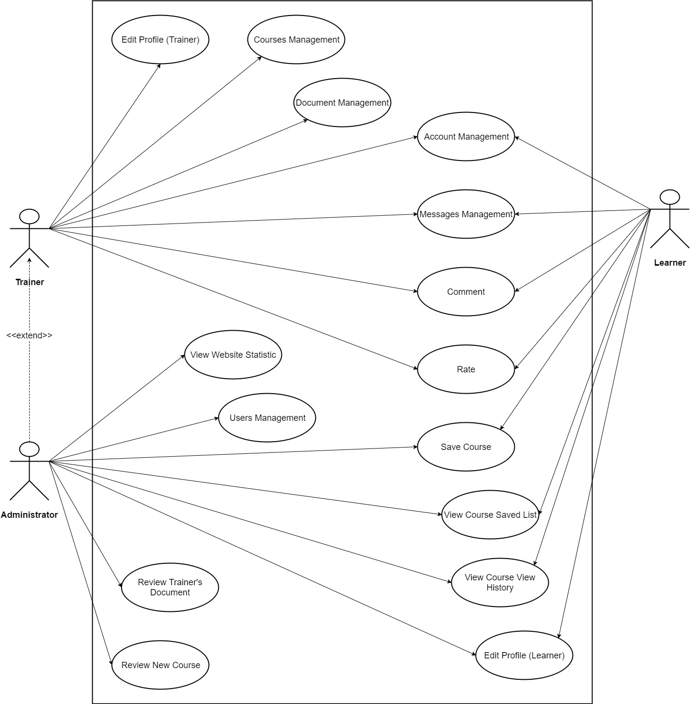

*Figure 3.3: Administrator, Trainer and Learner Use Case Diagram*

* + 1. **Guest Use Case Diagram**

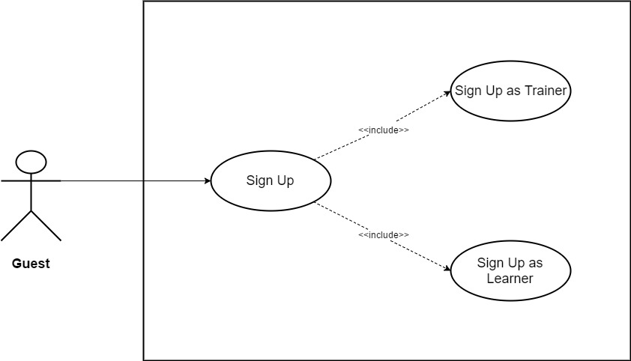

*Figure 3.4: Guest Use Case Diagram*

* + 1. **Administrator, Trainer, Learner, Guest Use Case Diagram**

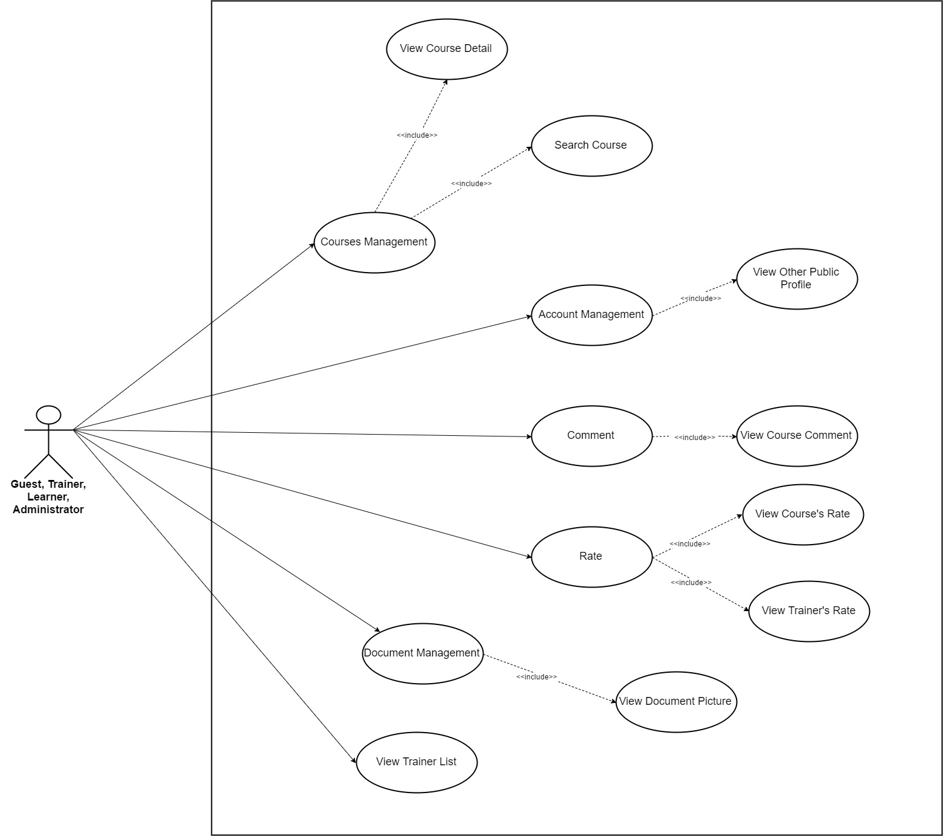

*Figure 3.5: Administrator, Trainer, Learner and Guest Use Case Diagram*

* + 1. **Use Case Diagram about Course Management**

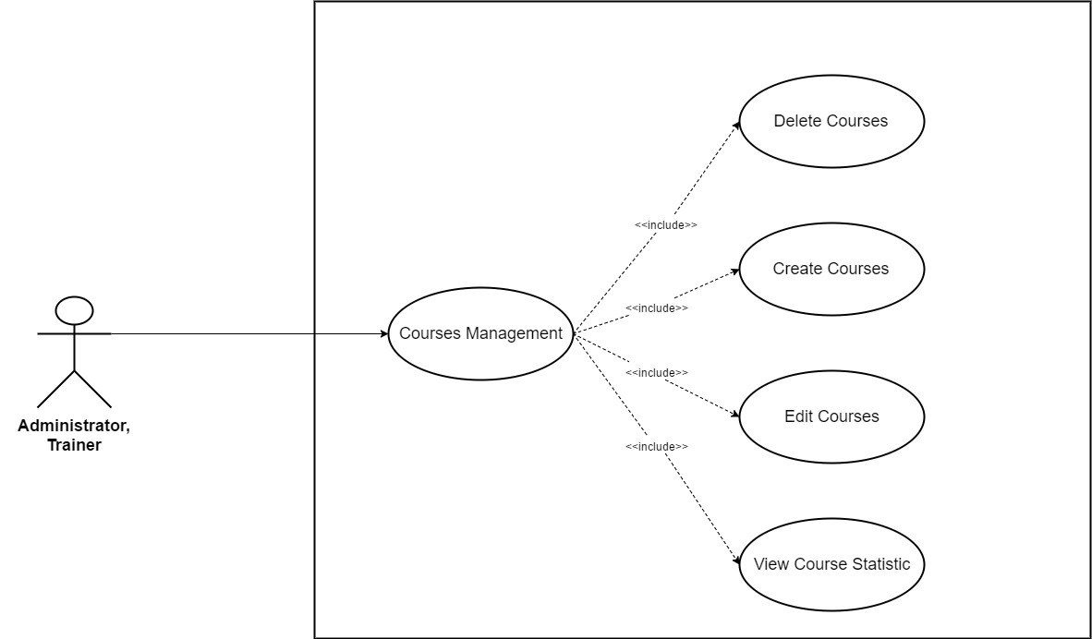

*Figure 3.6: Use Case Diagram about Course Management*

* + 1. **Use Case Diagram about Document Management**

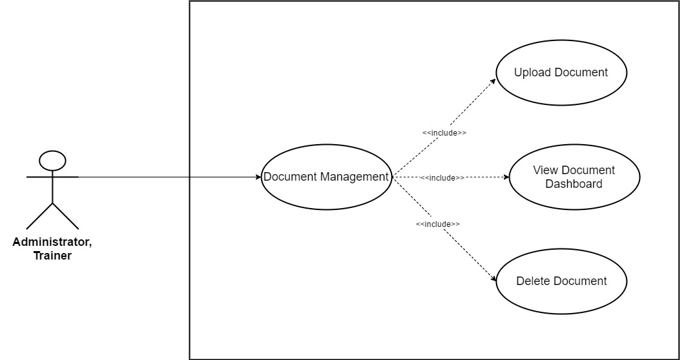

*Figure 3.7: Use Case Diagram about Document Management*

* + 1. **Use Case Diagram about Account Management**

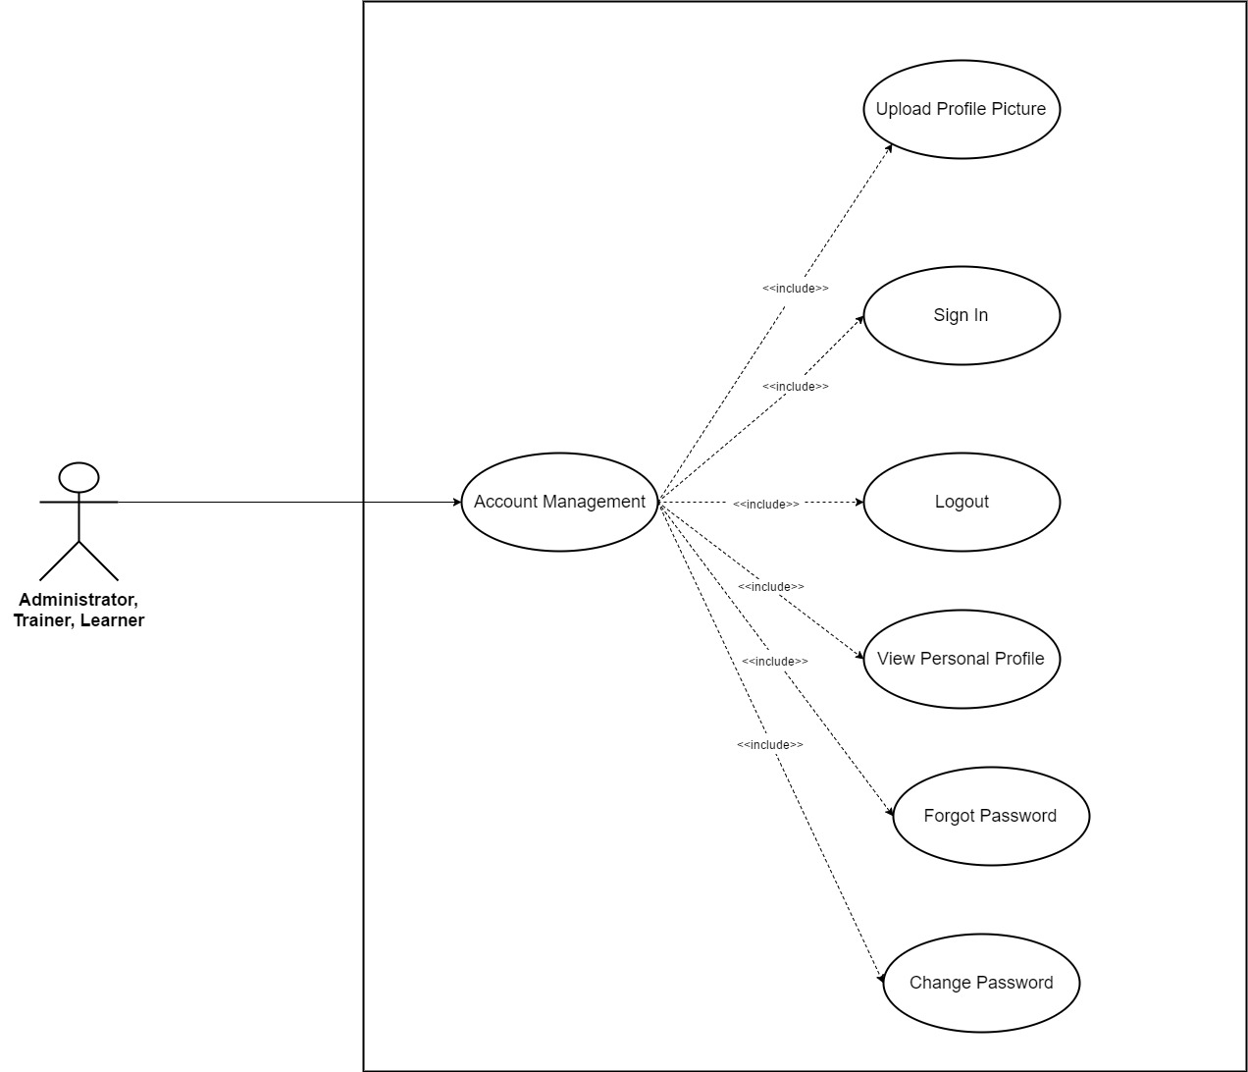

*Figure 3.8: Use Case Diagram about Account Management*

* + 1. **Use Case Diagram about Message Management**

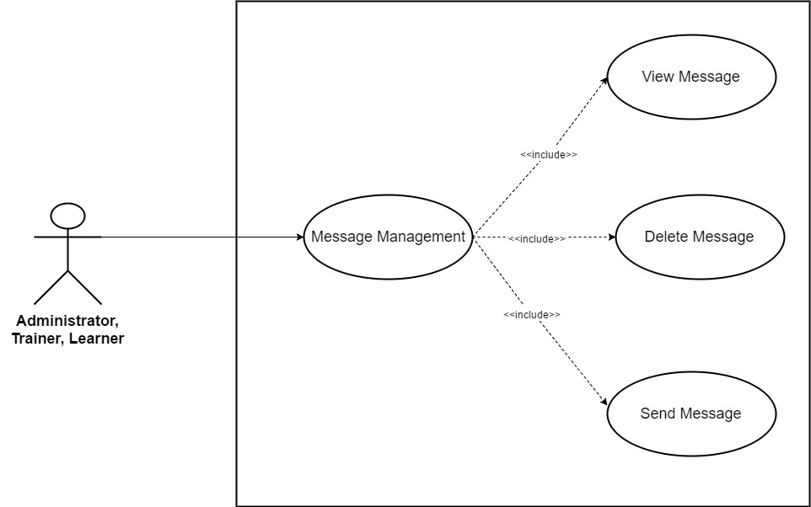

*Figure 3.9: Use Case Diagram about Message Management*

* + 1. **Use Case Diagram about Comment**

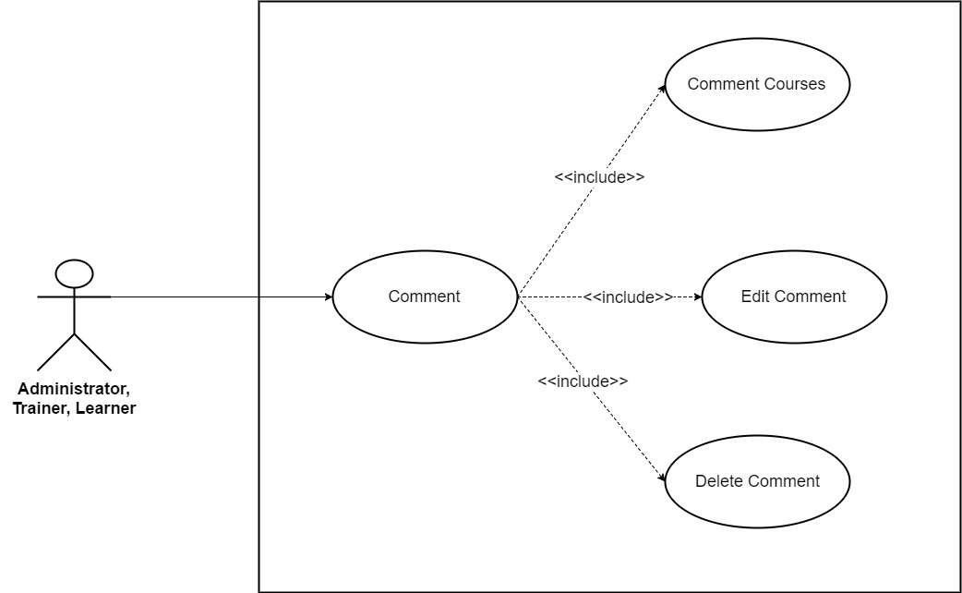

*Figure 3.10: Use Case Diagram about Comment*

* + 1. **Use Case Diagram about Rate**

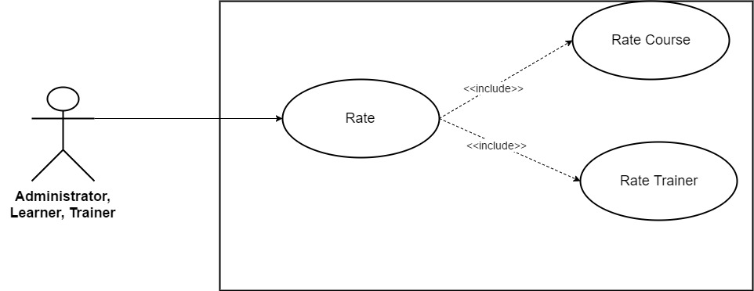

*Figure 3.11: Use Case Diagram about Rate*

* + 1. **Use Case Diagram about Users Management**

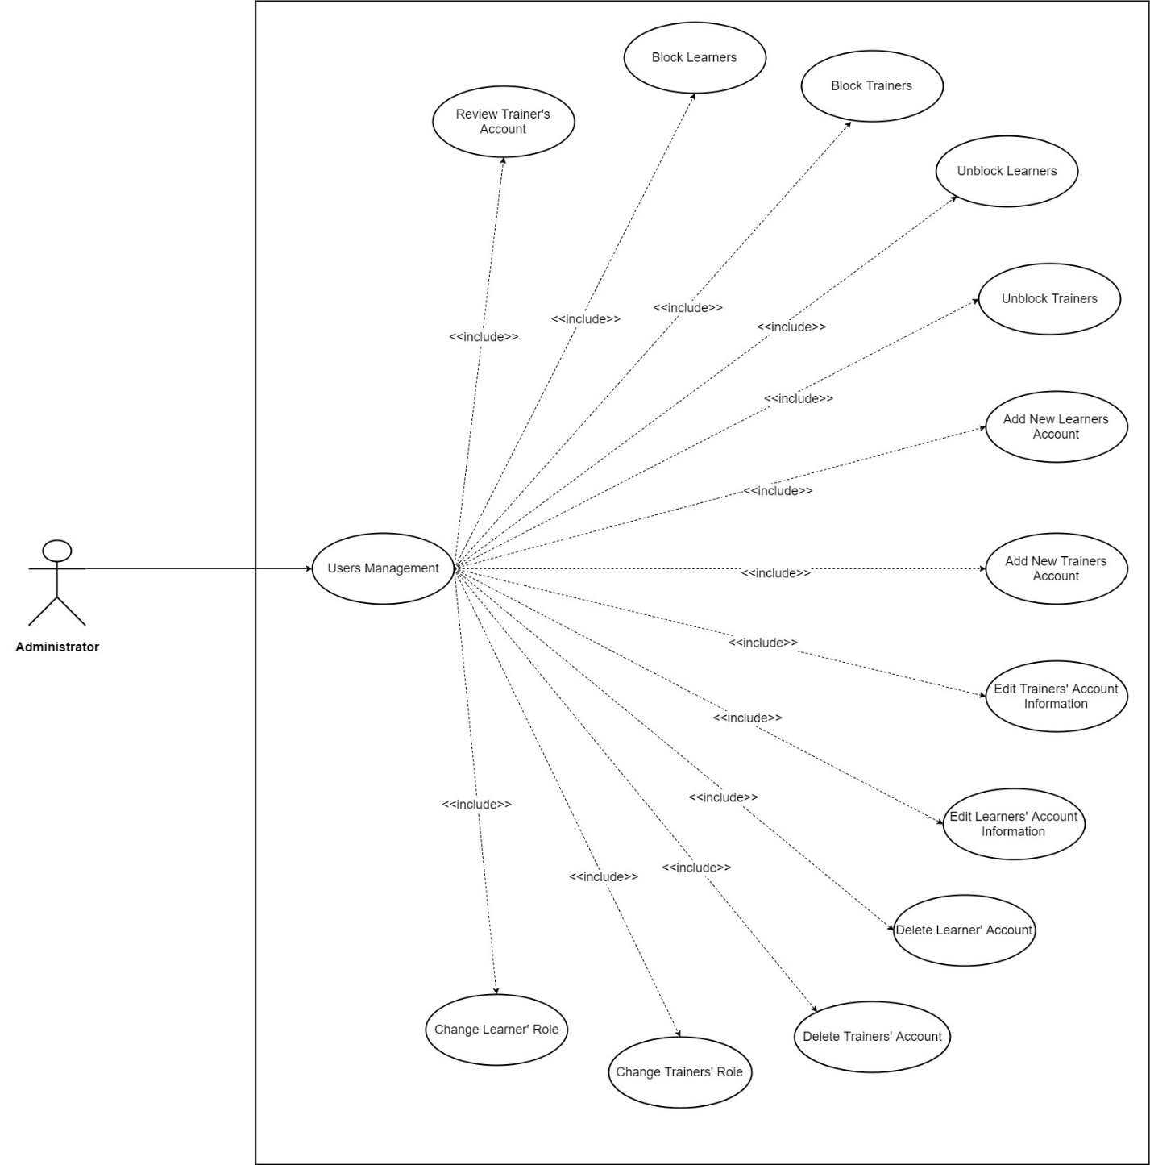

*Figure 3.12: Use Case Diagram about Users Management*

1. **Functional Requirements**
   1. **Business Rules**
   2. **Functionality**
      1. **Guest**

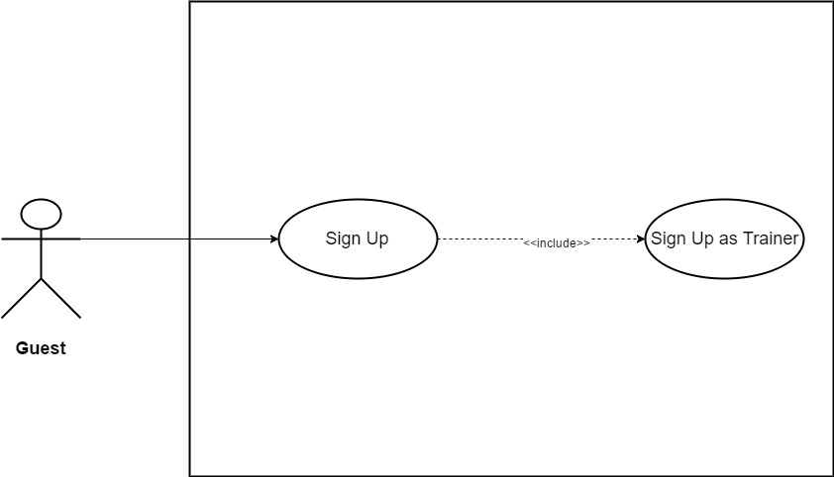

*Figure 3.13: Sign Up as Trainer*

|  |  |  |  |  |
| --- | --- | --- | --- | --- |
| **Use Case ID** | UC01 | | **Version** | 1.0 |
| **Use Case Name** | Sign Up as Trainer | | | |
| **Create By** | TruongTN | | **Last Updated** |  |
| **Primary Actor** | Guest | | **Secondary Actor** |  |
| **Description** | Create new account for *Trainer* | | | |
| **Pre-Conditions** | * User must have valid account. * Internet connection is required. | | | |
| **Post-Conditions** | * User account information is added into Database. * User can sign in as *Trainer* | | | |
| **Normal Flows** | | | | |
| **Step** | **Actor** | **Action** | | |
| 1 | Guest | Click on "Sign up" menu, the menu stays on the right side of search bar. | | |
| 2 | System | Display role choosing page. There are two roles that user can sign up for: *Trainer* and *Learner.* | | |
| 3 | Guest | Click “*Trainer”.* | | |
| 4 | System | Display “Sign Up” page which contain the following information:   * Sign Up via Google * Sign Up via Facebook * Email (Text Input) * Password (Text Input) * Confirm Password (Text Input) * Trainer Name (Text Input) * Fields (Combo Box) * Contact (Text Input) * Address (Text Input) * Introduction (Text Area) * Document. | | |
| 5 | Guest | Enter all required information. | | |
| 6 | Guest | Click “Sign Up” button. | | |
| 7 | System | Add account information into system Database. | | |
| 8 | System | Display Homepage. User appears as Trainer. | | |
|  | | | | |
| **Exception** | | | | |
| **EC1** | At step 5, all or more than one required fields are blank. | | | |
| **Step** | **Actor** | **Action** | | |
| 5.1 | Guest | Leave all required field blank. | | |
| 5.2 | Guest | Click “Sign Up” button. | | |
| 5.3 | System | Display message: “Please Fill In All Required Field!” | | |
| **EC2** | At step 5, *Email* is left blank. | | | |
| **Step** | **Actor** | **Action** | | |
| 5.1 | Guest | Leave *Email* field blank. | | |
| 5.2 | Guest | Click “Sign Up” button. | | |
| 5.3 | System | Display message: “Please Enter Email!” | | |
| **EC3** | At step 5, only *Password* is left blank. | | | |
| **Step** | **Actor** | **Action** | | |
| 5.1 | Guest | Leave *Password* field blank. | | |
| 5.2 | Guest | Click “Sign Up” button. | | |
| 5.3 | System | Display message: “Please Enter Password!” | | |
| **EC4** | At step 5, only *Trainer Name* is left blank. | | | |
| **Step** | **Actor** | **Action** | | |
| 5.1 | Guest | Leave *Trainer Name* field blank. | | |
| 5.2 | Guest | Click “Sign Up” button. | | |
| 5.3 | System | Display message: “Please Enter Trainer Name!” | | |
| **EC5** | At step 5, only *Fields* is not selected. | | | |
| **Step** | **Actor** | **Action** | | |
| 5.1 | Guest | Do not select *Fields.* | | |
| 5.2 | Guest | Click “Sign Up” button. | | |
| 5.3 | System | Display message: “Please Select Fields!” | | |
| **EC6** | At step 5, only *Contact* is left blank. | | | |
| **Step** | **Actor** | **Action** | | |
| 5.1 | Guest | Leave *Contact* field blank. | | |
| 5.2 | Guest | Click “Sign Up” button. | | |
| 5.3 | System | Display message: “Please Enter Password!” | | |
| **EC7** | At step 5, only *Address* is left blank. | | | |
| **Step** | **Actor** | **Action** | | |
| 5.1 | Guest | Leave *Address* field blank. | | |
| 5.2 | Guest | Click “Sign Up” button. | | |
| 5.3 | System | Display message: “Please Enter Address!” | | |
| **EC8** | At step 5, *Email* is invalid. (Incorrect *Email* format: abc@xyz) | | | |
| **Step** | **Actor** | **Action** | | |
| 5.1 | Guest | Enter invalid *Email*. | | |
| 5.2 | Guest | Click “Sign Up” button. | | |
| 5.3 | System | Display message: “Invalid Email!” | | |
| **EC9** | At step 5, *Password*’s length < 8. | | | |
| **Step** | **Actor** | **Action** | | |
| 5.1 | Guest | Enter *Password* less than 8 characters. | | |
| 5.2 | Guest | Click “Sign Up” button. | | |
| 5.3 | System | Display message: “Password must contains at least one upper case, one number, one special character and length must be >8!” | | |
| **EC10** | At step 5, *Password* does not contain any upper case. | | | |
| **Step** | **Actor** | **Action** | | |
| 5.1 | Guest | Enter *Password* that does not contain any upper case. | | |
| 5.2 | Guest | Click “Sign Up” button. | | |
| 5.3 | System | Display message: “Password must contains at least one upper case, one number, one special character and length must be >8!” | | |
| **EC11** | At step 5, *Password* does not contain any number. | | | |
| **Step** | **Actor** | **Action** | | |
| 5.1 | Guest | Enter *Password* that does not contain any number. | | |
| 5.2 | Guest | Click “Sign Up” button. | | |
| 5.3 | System | Display message: “Password must contains at least one upper case, one number, one special character and length must be >8!” | | |
| **EC12** | At step 5, *Password* does not contain at least one special character. | | | |
| **Step** | **Actor** | **Action** | | |
| 5.1 | Guest | Enter *Password* does not contain at least one special character. | | |
| 5.2 | Guest | Click “Sign Up” button. | | |
| 5.3 | System | Display message: “Password must contains at least one upper case, one number, one special character and length must be >8!” | | |
| **EC13** | At step 5, *Password* and *Confirm Password* do not match. | | | |
| **Step** | **Actor** | **Action** | | |
| 5.1 | Guest | Enter *Confirm Password* that does not match *Password.* | | |
| 5.2 | Guest | Click “Sign Up” button. | | |
| 5.3 | System | Display message: “Password does not match!” | | |
| **EC14** | At step 5, *Introduction*’s length > 200 character. | | | |
| **Step** | **Actor** | **Action** | | |
| 5.1 | Guest | Enter more than 200 character in *Introduction* field. | | |
| 5.2 | Guest | Click “Sign Up” button. | | |
| 5.3 | System | Display message: “Length must be < 200” | | |
| **EC15** | At step 5, User does not upload document. | | | |
| **Step** | **Actor** | **Action** | | |
| 5.1 | Guest | User does not upload document. | | |
| 5.2 | Guest | Click “Sign Up” button. | | |
| 5.3 | System | Display message: “Please upload at least one validate document such as University/College Graduation Certificate…” | | |
| **EC16** | At step 5, *Document* does not meet the format requirement. | | | |
| **Step** | **Actor** | **Action** | | |
| 5.1 | Guest | User upload wrong document’s format. | | |
| 5.2 | Guest | Click “Sign Up” button. | | |
| 5.3 | System | Display message: “Document’s format must be one of these following type: .pdf, .png, .jpeg!” | | |
| **EC17** | At step 5, Email address is already registered. | | | |
| **Step** | **Actor** | **Action** | | |
| 5.1 | Guest | Enter email address is already registered. | | |
| 5.2 | Guest | Click “Sign Up” button. | | |
| 5.3 | System | Display message: “The email address you have entered is already registered.” | | |
|  |  |  | | |
| **Priority** | High | | | |
| **Frequency of Use** | High | | | |
| **Business Rules** | BR1, BR2, BR3, BR4, BR5, BR6, BR17 | | | |

*Table 3.2: Sign Up as Trainer*

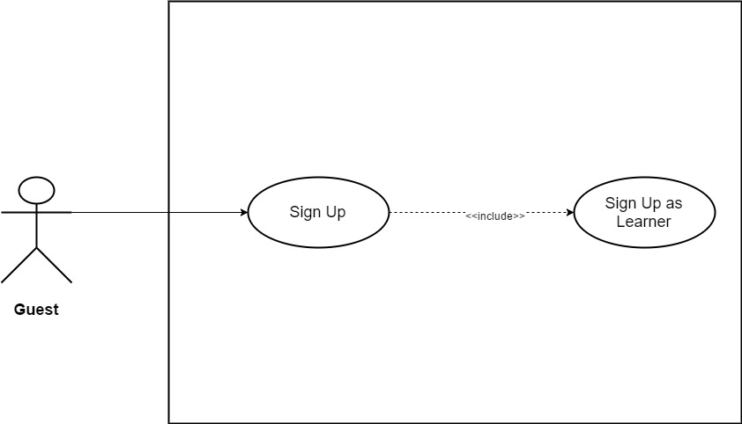

*Figure 3.14: Sign Up as Learner*

|  |  |  |  |  |
| --- | --- | --- | --- | --- |
| **Use Case ID** | UC02 | | **Version** | 1.0 |
| **Use Case Name** | Sign Up as Learner | | | |
| **Create By** | TruongTN | | **Last Updated** |  |
| **Primary Actor** | Guest | | **Secondary Actor** |  |
| **Description** | Create new account for *Learner* | | | |
| **Pre-Conditions** | * User must have valid account. * Internet connection is required. | | | |
| **Post-Conditions** | * User account information is added into Database. * User can sign in as *Learner* | | | |
| **Normal Flows** | | | | |
| **Step** | **Actor** | **Action** | | |
| 1 | Guest | Click on "Sign up" menu, the menu stays on the right side of search bar. | | |
| 2 | System | Display role choosing page. There are two roles that user can sign up for: *Trainer* and *Leraner.* | | |
| 3 | Guest | Click “*Learner”.* | | |
| 4 | System | Display “Sign Up” page which contain the following information:   * Sign Up via Google * Sign Up via Facebook * Email (Text Input) * Password (Text Input) * Confirm Password (Text Input) * First Name (Text Input) * Last Name (Text Input) * Gender (Radio Button) * Date of Birth (Date Picker) * Contact (Text Input) * Job (Text Input) * Introduction (Text Area) | | |
| 5 | Guest | Enter all required information. Gender default is “*Male*” | | |
| 6 | Guest | Click “Sign Up” button. | | |
| 7 | System | Add account information into system Database. | | |
| 8 | System | Display Homepage. User appears as *Learner*. | | |
|  | | | | |
| **Exception** | | | | |
| **EC1** | At step 5, all or more than one required fields are blank. | | | |
| **Step** | **Actor** | **Action** | | |
| 5.1 | Guest | Leave all required field blank. | | |
| 5.2 | Guest | Click “Sign Up” button. | | |
| 5.3 | System | Display message: “Please Fill In All Required Field!” | | |
| **EC2** | At step 5, *Email* is left blank. | | | |
| **Step** | **Actor** | **Action** | | |
| 5.1 | Guest | Leave *Email* field blank. | | |
| 5.2 | Guest | Click “Sign Up” button. | | |
| 5.3 | System | Display message: “Please Enter Email!” | | |
| **EC3** | At step 5, only *Password* is left blank. | | | |
| **Step** | **Actor** | **Action** | | |
| 5.1 | Guest | Leave *Password* field blank. | | |
| 5.2 | Guest | Click “Sign Up” button. | | |
| 5.3 | System | Display message: “Please Enter Password!” | | |
| **EC4** | At step 5, only *First Name* is left blank. | | | |
| **Step** | **Actor** | **Action** | | |
| 5.1 | Guest | Leave *First Name* field blank. | | |
| 5.2 | Guest | Click “Sign Up” button. | | |
| 5.3 | System | Display message: “Please Enter Your First Name!” | | |
| **EC5** | At step 5, only *Last Name* is left blank. | | | |
| **Step** | **Actor** | **Action** | | |
| 5.1 | Guest | Leave *Last Name* field blank. | | |
| 5.2 | Guest | Click “Sign Up” button. | | |
| 5.3 | System | Display message: “Please Enter Your Last Name!” | | |
| **EC6** | At step 5, only *Date of Birth* is not selected. | | | |
| **Step** | **Actor** | **Action** | | |
| 5.1 | Guest | Do not select *Date of Birth.* | | |
| 5.2 | Guest | Click “Sign Up” button. | | |
| 5.3 | System | Display message: “Please Select Date of Birth!” | | |
| **EC7** | At step 5, only *Contact* is left blank. | | | |
| **Step** | **Actor** | **Action** | | |
| 5.1 | Guest | Leave *Contact* field blank. | | |
| 5.2 | Guest | Click “Sign Up” button. | | |
| 5.3 | System | Display message: “Please Enter Password!” | | |
| **EC8** | At step 5, only *Job* is left blank. | | | |
| **Step** | **Actor** | **Action** | | |
| 5.1 | Guest | Leave *Job* field blank. | | |
| 5.2 | Guest | Click “Sign Up” button. | | |
| 5.3 | System | Display message: “Please Enter Job!” | | |
| **EC9** | At step 5, *Email* is invalid. (Incorrect *Email* format: abc@xyz) | | | |
| **Step** | **Actor** | **Action** | | |
| 5.1 | Guest | Enter invalid *Email*. | | |
| 5.2 | Guest | Click “Sign Up” button. | | |
| 5.3 | System | Display message: “Invalid Email!” | | |
| **EC10** | At step 5, *Password*’s length < 8. | | | |
| **Step** | **Actor** | **Action** | | |
| 5.1 | Guest | Enter *Password* less than 8 characters. | | |
| 5.2 | Guest | Click “Sign Up” button. | | |
| 5.3 | System | Display message: “Password must contains at least one upper case, one number, one special character and length must be >8!” | | |
| **EC11** | At step 5, *Password* does not contain any upper case. | | | |
| **Step** | **Actor** | **Action** | | |
| 5.1 | Guest | Enter *Password* that does not contain any upper case. | | |
| 5.2 | Guest | Click “Sign Up” button. | | |
| 5.3 | System | Display message: “Password must contains at least one upper case, one number, one special character and length must be >8!” | | |
| **EC12** | At step 5, *Password* does not contain any number. | | | |
| **Step** | **Actor** | **Action** | | |
| 5.1 | Guest | Enter *Password* that does not contain any number. | | |
| 5.2 | Guest | Click “Sign Up” button. | | |
| 5.3 | System | Display message: “Password must contains at least one upper case, one number, one special character and length must be >8!” | | |
| **EC13** | At step 5, *Password* does not contain at least one special character. | | | |
| **Step** | **Actor** | **Action** | | |
| 5.1 | Guest | Enter *Password* does not contain at least one special character. | | |
| 5.2 | Guest | Click “Sign Up” button. | | |
| 5.3 | System | Display message: “Password must contains at least one upper case, one number, one special character and length must be >8!” | | |
| **EC14** | At step 5, *Password* and *Confirm Password* do not match. | | | |
| **Step** | **Actor** | **Action** | | |
| 5.1 | Guest | Enter *Confirm Password* that does not match *Password.* | | |
| 5.2 | Guest | Click “Sign Up” button. | | |
| 5.3 | System | Display message: “Password does not match!” | | |
| **EC15** | At step 5, *Introduction*’s length > 200 character. | | | |
| **Step** | **Actor** | **Action** | | |
| 5.1 | Guest | Enter more than 200 character in *Introduction* field. | | |
| 5.2 | Guest | Click “Sign Up” button. | | |
| 5.3 | System | Display message: “Length must be < 200” | | |
| **EC16** | At step 5, Email address is already registered. | | | |
| **Step** | **Actor** | **Action** | | |
| 5.1 | Guest | Enter email address is already registered. | | |
| 5.2 | Guest | Click “Sign Up” button. | | |
| 5.3 | System | Display message: “The email address you have entered is already registered.” | | |
|  |  |  | | |
| **Priority** | High | | | |
| **Frequency of Use** | High | | | |
| **Business Rules** | BR1, BR2, BR3, BR4, BR5, BR6, BR17 | | | |

*Table 3.3: Sign Up as Learner*

* + 1. **Administrator/Trainer/Learner**

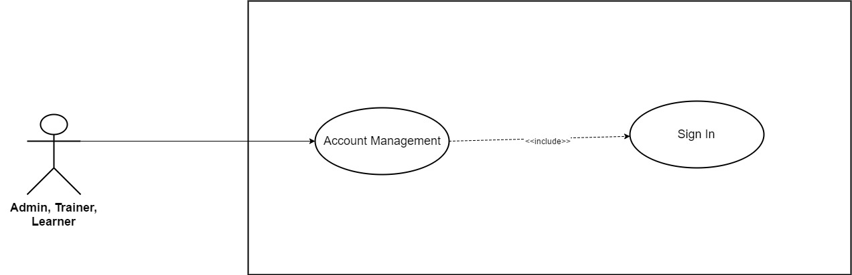 *Figure 3.15: Sign In*

|  |  |  |  |  |
| --- | --- | --- | --- | --- |
| **Use Case ID** | UC03 | | **Version** | 1.0 |
| **Use Case Name** | Sign In | | | |
| **Create By** | TruongTN | | **Last Updated** |  |
| **Primary Actor** | Trainer/Learner | | **Secondary Actor** | Administrator |
| **Description** | Sign in into System system | | | |
| **Pre-Conditions** | * User must have System’s account. * Internet connection is required. | | | |
| **Post-Conditions** | * User’s account is logged into system * Send user to Homepage after sign in. | | | |
| **Normal Flows** | | | | |
| **Step** | **Actor** | **Action** | | |
| 1 | Trainer/Learner | Click “Sign In” in the header to the right of Sign Up button. | | |
| 2 | System | Show “Sign In” window. | | |
| 3 | Trainer/Learner | Enter Email and Password. | | |
| 4 | Trainer/Learner | Click “Sign In”. | | |
| 5 | System | Log account into System’s system. | | |
| 6 | System | Send Trainer/Learner to Homepage. | | |
|  | | | | |
| **Exception** | | | | |
| **EC1** | At step 3, Email and Password are left blank.. | | | |
| **Step** | **Actor** | **Action** | | |
| 3.1 | Trainer/Learner | Leave Email and Password blank. | | |
| 3.2 | Trainer/Learner | Click “Sign In” button. | | |
| 3.3 | System | Display message: “Please Enter Email and Password!” | | |
| **EC2** | At step 3, Email is left blank. | | | |
| **Step** | **Actor** | **Action** | | |
| 3.1 | Trainer/Learner | Leave Email blank. | | |
| 3.2 | Trainer/Learner | Click “Sign In” button | | |
| 3.3 | System | Display message: “Please Enter Your Email!” | | |
| **EC3** | At step 3, Password is left blank. | | | |
| **Step** | **Actor** | **Action** | | |
| 3.1 | Trainer/Learner | Leave Password blank. | | |
| 3.2 | Trainer/Learner | Click “Sign In” button | | |
| 3.3 | System | Display message: “Please Enter Your Password!” | | |
| **EC4** | At step 3, Trainer/Learner enter wrong or un-register Email. | | | |
| **Step** | **Actor** | **Action** | | |
| 3.1 | Trainer/Learner | Enter wrong or un-register Email. | | |
| 3.2 | Trainer/Learner | Click “Sign In” button. | | |
| 3.3 | System | Display message: “The email address that you’re entered doesn’t match any account. Sign up for an account!”. | | |
| **EC5** | At step 4, Trainer/Learner enter wrong Password. | | | |
| **Step** | **Actor** | **Action** | | |
| 3.1 | Trainer/Learner | Enter wrong password. | | |
| 3.2 | Trainer/Learner | Click “Sign In” button | | |
| 3.3 | System | Display message: “The password that you’re entered is incorrect!”. | | |
|  |  |  | | |
| **Priority** | High | | | |
| **Frequency of Use** | High | | | |
| **Business Rules** | BR18 | | | |

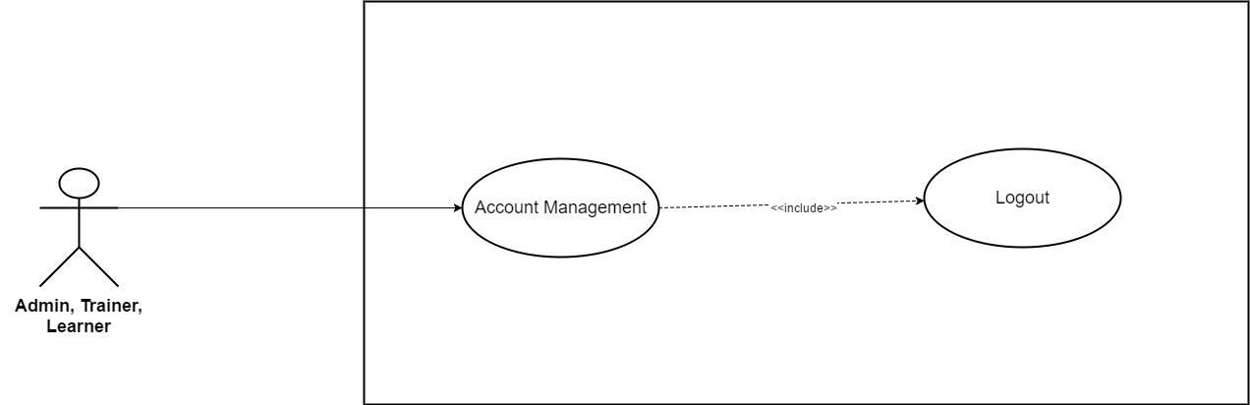

*Figure 3.16: Logout*

|  |  |  |  |  |
| --- | --- | --- | --- | --- |
| **Use Case ID** | UC04 | | **Version** | 1.0 |
| **Use Case Name** | Logout | | | |
| **Create By** | TruongTN | | **Last Updated** |  |
| **Primary Actor** | Trainer/Learner | | **Secondary Actor** | Administrator |
| **Description** | Logout of the system | | | |
| **Pre-Conditions** | * User must login first. * Internet connection is required. | | | |
| **Post-Conditions** | * User’s account is logged out of system. * Send user to homepage as Guest. | | | |
| **Normal Flows** | | | | |
| **Step** | **Actor** | **Action** | | |
| 1 | Trainer/Learner | Move mouse to Trainer/Learner’s name to the right of search bar. | | |
| 2 | System | Display drop-down list. | | |
| 3 | Trainer/Learner | Click “Logout” | | |
| 4 | System | Log user out of system. | | |
| 5 | System | Send user to Homepage as Guest. | | |
|  | | | | |
|  |  |  | | |
| **Priority** | High | | | |
| **Frequency of Use** | High | | | |
| **Business Rules** |  | | | |

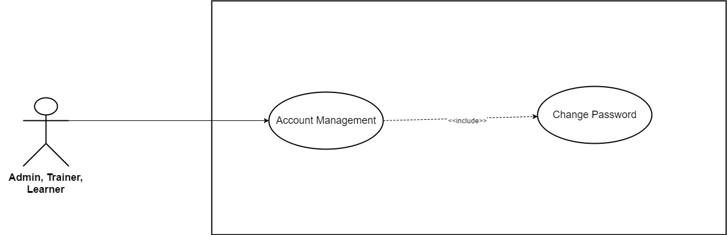

*Figure 3.17: Change Password*

|  |  |  |  |  |  |
| --- | --- | --- | --- | --- | --- |
| **Use Case ID** | UC05 | | | **Version** | 1.0 |
| **Use Case Name** | Change Password | | | | |
| **Create By** | TruongTN | | | **Last Updated** |  |
| **Primary Actor** | Trainer/Learner | | | **Secondary Actor** | Administrator |
| **Description** | Change password. | | | | |
| **Pre-Conditions** | * User must login first. * Internet connection is required. | | | | |
| **Post-Conditions** | * New password is saved and updated into system. | | | | |
| **Normal Flows** | | | | | |
| **Step** | **Actor** | | **Action** | | |
| 1 | Trainer/Learner | | Move mouse to Trainer/Learner’s name to the right of search bar. | | |
| 2 | System | | Display drop-down list. | | |
| 3 | Trainer/Learner | | Click “Change Password” | | |
| 4 | System | | Send Trainer to “Change Password” page | | |
| 5 | System | | Display “Change Password” page which contain the following information:   * Email * Current Password * New Password * Confirm New Password | | |
| 6 | Trainer/Learner | | Enter current password, new password and confirm new password. Email can’t be edit. | | |
| 7 | Trainer/Learner | | Click “Save” button. | | |
| 8 | System | | Update password into system’s Database. | | |
| 9 | System | | Display “Change Password” page with message: “Change Password Successfully!” | | |
|  | | | | | |
| **Exception** | | | | | |
| **EC1** | At step 6, only Current Password is left blank | | | | |
| **Step** | **Actor** | | **Action** | | |
| 6.1 | Trainer/Learner | | Leave only Current Password blank. | | |
| 6.2 | Trainer/Learner | | Click “Save” button. | | |
| 6.3 | System | | Display message: “Please Enter Your Current Password!” | | |
| **EC2** | At step 5, only New Password is left blank. | | | | |
| **Step** | **Actor** | | **Action** | | |
| 6.1 | Trainer/Learner | | Leave New Password blank. | | |
| 6.2 | Trainer/Learner | | Click “Save” button. | | |
| 6.3 | System | | Display message: “Please Enter New Password!” | | |
| **EC3** | At step 6, only Confirm New Password is blank. | | | | |
| **Step** | **Actor** | | **Action** | | |
| 6.1 | Trainer/Learner | | Leave Confirm New Password blank. | | |
| 6.2 | Trainer/Learner | | Click “Save” button. | | |
| 6.3 | System | | Display message: “Please Confirm New Password!” | | |
| **EC4** | At step 6, New Password and Confirm New Password does not match. | | | | |
| **Step** | **Actor** | | **Action** | | |
| 6.1 | Trainer/Learner | | New Password and Confirm New Password does not match. | | |
| 6.2 | Trainer/Learner | | Click “Save” button. | | |
| 6.3 | System | | Display message: “New Password and Confirm does not match!” | | |
| **EC5** | At step 6, Trainer/Learner enter wrong current password. | | | | |
| **Step** | **Actor** | | **Action** | | |
| 6.1 | Trainer/Learner | | Enter wrong current password. | | |
| 6.2 | Trainer/Learner | | Click “Save” button. | | |
| 6.3 | System | | Display message: “The Current Password that you’re entered is incorrect. Please enter again!” | | |
| **EC6** | At step 6, New Password’s length < 8. | | | | |
| **Step** | **Actor** | **Action** | | | |
| 6.1 | Guest | Enter New Password less than 8 characters. | | | |
| 6.2 | Guest | Click “Sign Up” button. | | | |
| 6.3 | System | Display message: “Password must contains at least one upper case, one number, one special character and length must be >8!” | | | |
| **EC7** | At step 6, New Password does not contain any upper case. | | | | |
| **Step** | **Actor** | **Action** | | | |
| 6.1 | Guest | Enter New Password that does not contain any upper case. | | | |
| 6.2 | Guest | Click “Sign Up” button. | | | |
| 6.3 | System | Display message: “Password must contains at least one upper case, one number, one special character and length must be >8!” | | | |
| **EC8** | At step 6, New Password does not contain any number. | | | | |
| **Step** | **Actor** | **Action** | | | |
| 6.1 | Guest | Enter New Password that does not contain any number. | | | |
| 6.2 | Guest | Click “Sign Up” button. | | | |
| 6.3 | System | Display message: “Password must contains at least one upper case, one number, one special character and length must be >8!” | | | |
| **EC9** | At step 6, New Password does not contain at least one special character. | | | | |
| **Step** | **Actor** | **Action** | | | |
| 6.1 | Guest | Enter New Password does not contain at least one special character. | | | |
| 6.2 | Guest | Click “Sign Up” button. | | | |
| 6.3 | System | Display message: “Password must contains at least one upper case, one number, one special character and length must be >8!” | | | |
|  |  |  | | | |
| **Priority** | High | | | | |
| **Frequency of Use** | High | | | | |
| **Business Rules** |  | | | | |

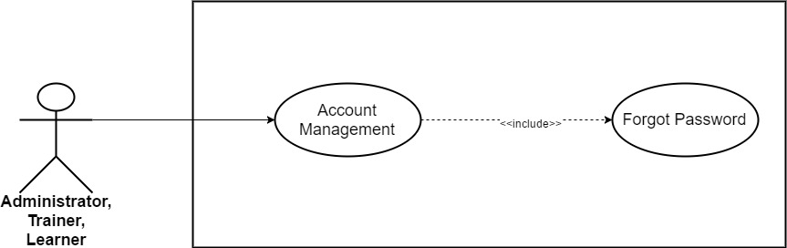

*Figure 3.17: Forget Password*

|  |  |  |  |  |  |
| --- | --- | --- | --- | --- | --- |
| **Use Case ID** | UC06 | | | **Version** | 1.0 |
| **Use Case Name** | Forget Password | | | | |
| **Create By** | TruongTN | | | **Last Updated** |  |
| **Primary Actor** | Trainer/Learner | | | **Secondary Actor** | Administrator |
| **Description** | Users use in case they forget their password. | | | | |
| **Pre-Conditions** | * Must have WeTeach’s account * Internet connection is required. | | | | |
| **Post-Conditions** | * Password reset and send new password to user’s email. | | | | |
| **Normal Flows** | | | | | |
| **Step** | **Actor** | | **Action** | | |
| 1 | Trainer/Learner | | Click “Sign In”. | | |
| 2 | System | | Display drop-down list. | | |
| 3 | Trainer/Learner | | Click “Forget Password!” | | |
| 4 | System | | Send Trainer to reset password page | | |
| 5 | Trainer/Learner | | Input email address that used to sign up into WeTeach. | | |
| 6 | System | | Send new password to their email. | | |
|  | | | | | |
|  |  |  | | | |
| **Priority** | High | | | | |
| **Frequency of Use** | High | | | | |
| **Business Rules** |  | | | | |

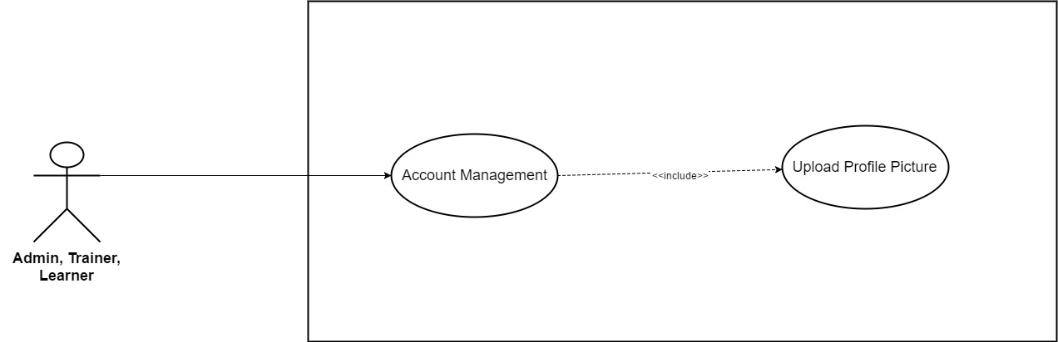

*Figure 3.18: Upload Profile Picture*

|  |  |  |  |  |
| --- | --- | --- | --- | --- |
| **Use Case ID** | UC07 | | **Version** | 1.0 |
| **Use Case Name** | Upload Profile Picture | | | |
| **Create By** | TruongTN | | **Last Updated** |  |
| **Primary Actor** | Trainer/Learner | | **Secondary Actor** | Administrator |
| **Description** | Upload profile picture. | | | |
| **Pre-Conditions** | * User must login first. * Internet connection is required. | | | |
| **Post-Conditions** | * Profile picture is saved into system. | | | |
| **Normal Flows** | | | | |
| **Step** | **Actor** | **Action** | | |
| 1 | Trainer/Learner | Move mouse to Trainer/Learner’s name to the right of search bar. | | |
| 2 | System | Display drop-down list. | | |
| 3 | Trainer/Learner | Click “My Profile” | | |
| 4 | System | Send Trainer to “My Profile” page | | |
| 5 | Trainer/Learner | Click on profile picture. | | |
| 6 | Trainer/Learner | Choose picture on device. | | |
| 7 | Trainer/Learner | Double click on the picture or click “Open” | | |
| 8 | System | Display message: “Your picture has been uploaded!” | | |
|  | | | | |
| **Exception** | | | | |
| **UC1** | At step 7, Trainer/Learner upload picture with different dimensions. | | | |
| **Step** | **Actor** | **Action** | | |
| 7.1 | Trainer/Learner | Upload picture with different dimensions. | | |
| 7.2 | System | Crop to fit a square. | | |
|  |  |  | | |
| **Priority** | High | | | |
| **Frequency of Use** | High | | | |
| **Business Rules** |  | | | |

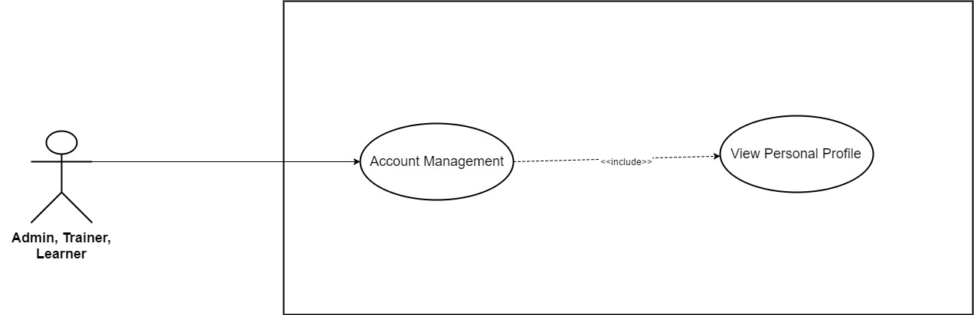

*Figure 3.19: View Personal Profile*

|  |  |  |  |  |
| --- | --- | --- | --- | --- |
| **Use Case ID** | UC08 | | **Version** | 1.0 |
| **Use Case Name** | View Personal Profile | | | |
| **Create By** | TruongTN | | **Last Updated** |  |
| **Primary Actor** | Trainer/Learner | | **Secondary Actor** | Administrator |
| **Description** | View Personal Profile | | | |
| **Pre-Conditions** | * User must login first. * Internet connection is required. | | | |
| **Post-Conditions** | * Display user personal profile. | | | |
| **Normal Flows** | | | | |
| **Step** | **Actor** | **Action** | | |
| 1 | Trainer/Learner | Move mouse to Trainer/Learner’s name to the right of search bar. | | |
| 2 | System | Display drop-down list. | | |
| 3 | Trainer/Learner | Click “My Profile” | | |
| 4 | System | Send Trainer/Learner to My Profile page | | |
| 5 | System | Display “My Profile” page which contain the following information:   * Email * Trainer Name * Fields * Contact * Address * Introduction | | |
|  |  |  | | |
| **Priority** | High | | | |
| **Frequency of Use** | High | | | |
| **Business Rules** |  | | | |

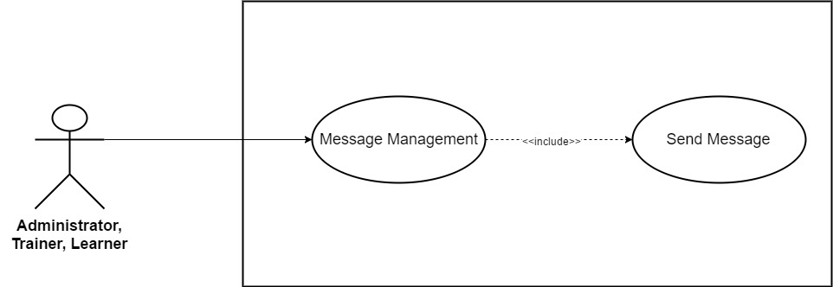

*Figure 3.20: Send Message*

|  |  |  |  |  |
| --- | --- | --- | --- | --- |
| **Use Case ID** | UC09 | | **Version** | 1.0 |
| **Use Case Name** | Send Message | | | |
| **Create By** | TruongTN | | **Last Updated** |  |
| **Primary Actor** | Trainer/Learner | | **Secondary Actor** | Administrator |
| **Description** | Send Message | | | |
| **Pre-Conditions** | * User must login first. * Internet connection is required. | | | |
| **Post-Conditions** | * Display messages page. | | | |
| **Normal Flows** | | | | |
| **Step** | **Actor** | **Action** | | |
| 1 | Trainer/Learner | Click the name of user that want to send message to. | | |
| 2 | System | Display public profile. | | |
| 3 | Trainer/Learner | Click “Send Message” | | |
| 4 | System | Pop up send message window. | | |
| 5 | Trainer/Learner | Input message. | | |
| 6 | Trainer/Learner | Click “Send” or enter. | | |
| 7 | System | Send message to receiver. | | |
|  | | | | |
| **Priority** | High | | | |
| **Frequency of Use** | High | | | |
| **Business Rules** |  | | | |

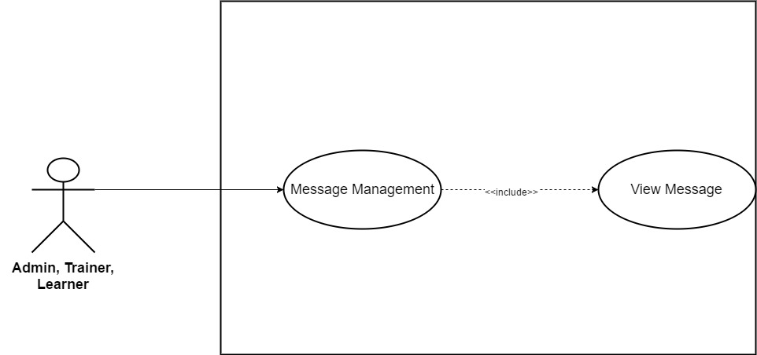

*Figure 3.21: View Message*

|  |  |  |  |  |
| --- | --- | --- | --- | --- |
| **Use Case ID** | UC10 | | **Version** | 1.0 |
| **Use Case Name** | View Message | | | |
| **Create By** | TruongTN | | **Last Updated** |  |
| **Primary Actor** | Trainer/Learner | | **Secondary Actor** | Administrator |
| **Description** | View Messages | | | |
| **Pre-Conditions** | * User must login first. * Internet connection is required. | | | |
| **Post-Conditions** | * Display messages page. | | | |
| **Normal Flows** | | | | |
| **Step** | **Actor** | **Action** | | |
| 1 | Trainer/Learner | Move mouse to Trainer/Learner’s name to the right of search bar. | | |
| 2 | System | Display drop-down list. | | |
| 3 | Trainer/Learner | Click “My Messages” | | |
| 4 | System | Send Trainer to “My Messages” page | | |
| 5 | Trainer/Learner | Click on messages to read. | | |
|  | | | | |
| **Priority** | High | | | |
| **Frequency of Use** | High | | | |
| **Business Rules** |  | | | |

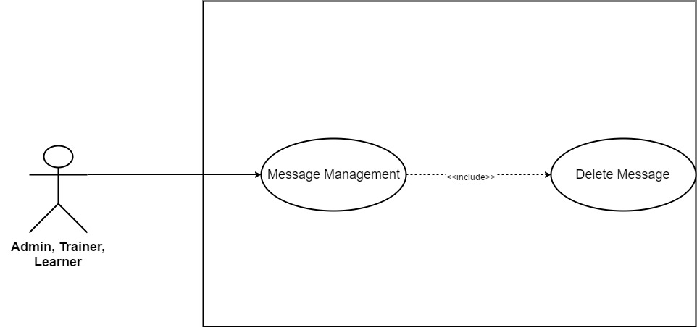

*Figure 3.22: Delete Message*

|  |  |  |  |  |
| --- | --- | --- | --- | --- |
| **Use Case ID** | UC11 | | **Version** | 1.0 |
| **Use Case Name** | Delete Message | | | |
| **Create By** | TruongTN | | **Last Updated** |  |
| **Primary Actor** | Trainer, Learner | | **Secondary Actor** | Administrator |
| **Description** | Delete Message | | | |
| **Pre-Conditions** |  | | | |
| **Post-Conditions** |  | | | |
| **Normal Flows** | | | | |
| **Step** | **Actor** | **Action** | | |
| 1 | Trainer, Learner | Move mouse to Trainer/Learner’s name to the right of search bar. | | |
| 2 | System | Display drop-down list. | | |
| 3 | Trainer, Learner, | Click “My Message” | | |
| 4 | System | Send to “My Profile” page | | |
| 5 | Trainer, Learner | Select message that needed to be delete. | | |
| 6 | Trainer, Learner | Click trash icon to delete. | | |
| 7 | System | Delete message out of database. | | |
|  | | | | |
|  | | | | |
| **Priority** | High | | | |
| **Frequency of Use** | High | | | |
| **Business Rules** |  | | | |

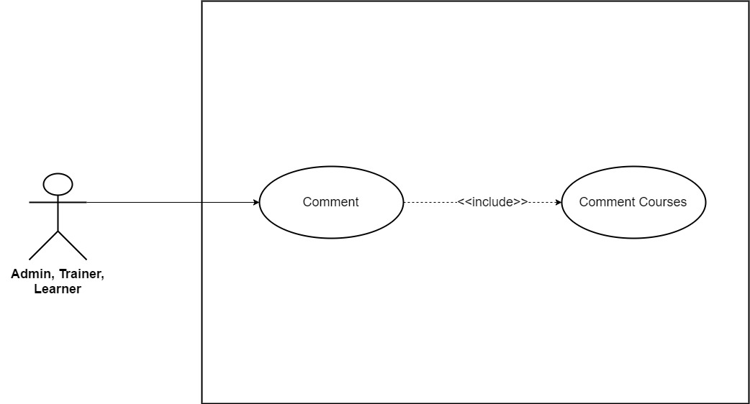

*Figure 3.23: Comment Courses*

|  |  |  |  |  |
| --- | --- | --- | --- | --- |
| **Use Case ID** | UC12 | | **Version** | 1.0 |
| **Use Case Name** | Comment Courses | | | |
| **Create By** | TruongTN | | **Last Updated** |  |
| **Primary Actor** | Trainer, Learner | | **Secondary Actor** | Administrator |
| **Description** | Comment Courses | | | |
| **Pre-Conditions** |  | | | |
| **Post-Conditions** |  | | | |
| **Normal Flows** | | | | |
| **Step** | **Actor** | **Action** | | |
| 1 | Trainer, Learner, Administrator | Scroll down course detail page. | | |
| 2 | System | Display comment section. | | |
| 3 | Trainer, Learner, Administrator | Input comment. | | |
| 4 | System | Update new comment into database. | | |
|  | | | | |
|  | | | | |
| **Priority** | High | | | |
| **Frequency of Use** | High | | | |
| **Business Rules** |  | | | |

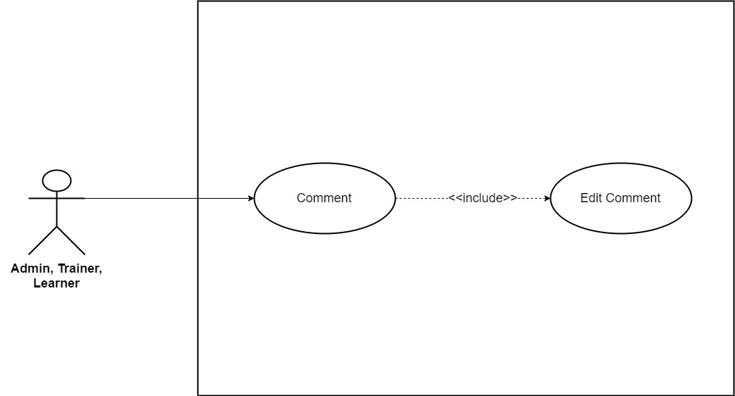

*Figure 3.24: Edit Comment*

|  |  |  |  |  |
| --- | --- | --- | --- | --- |
| **Use Case ID** | UC13 | | **Version** | 1.0 |
| **Use Case Name** | Edit Comment | | | |
| **Create By** | TruongTN | | **Last Updated** |  |
| **Primary Actor** | Trainer, Learner | | **Secondary Actor** | Administrator |
| **Description** | Edit Comment | | | |
| **Pre-Conditions** |  | | | |
| **Post-Conditions** |  | | | |
| **Normal Flows** | | | | |
| **Step** | **Actor** | **Action** | | |
| 1 | Trainer, Learner, Administrator | Choose comment that want to edit. | | |
| 2 | Trainer, Learner, Administrator | Click “Edit”. | | |
| 3 | System | Display input field. | | |
| 4 | Trainer, Learner, Administrator | Edit comment. | | |
| 5 | Trainer, Learner, Administrator | Click “Save”. | | |
| 6 | System | Save new comment into database | | |
|  | | | | |
|  | | | | |
| **Priority** | High | | | |
| **Frequency of Use** | High | | | |
| **Business Rules** |  | | | |

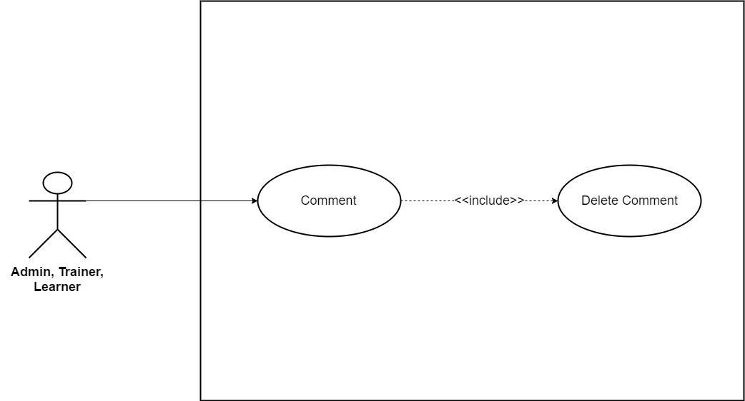

*Figure 3.25: Delete Comment*

|  |  |  |  |  |
| --- | --- | --- | --- | --- |
| **Use Case ID** | UC14 | | **Version** | 1.0 |
| **Use Case Name** | Delete Comment | | | |
| **Create By** | TruongTN | | **Last Updated** |  |
| **Primary Actor** | Trainer, Learner | | **Secondary Actor** | Administrator |
| **Description** | Edit Comment | | | |
| **Pre-Conditions** |  | | | |
| **Post-Conditions** |  | | | |
| **Normal Flows** | | | | |
| **Step** | **Actor** | **Action** | | |
| 1 | Trainer, Learner, Administrator | Choose comment that want to delete. | | |
| 2 | Trainer, Learner, Administrator | Click “Delete”. | | |
| 3 | System | Delete comment from database. | | |
|  | | | | |
|  | | | | |
| **Priority** | High | | | |
| **Frequency of Use** | High | | | |
| **Business Rules** |  | | | |

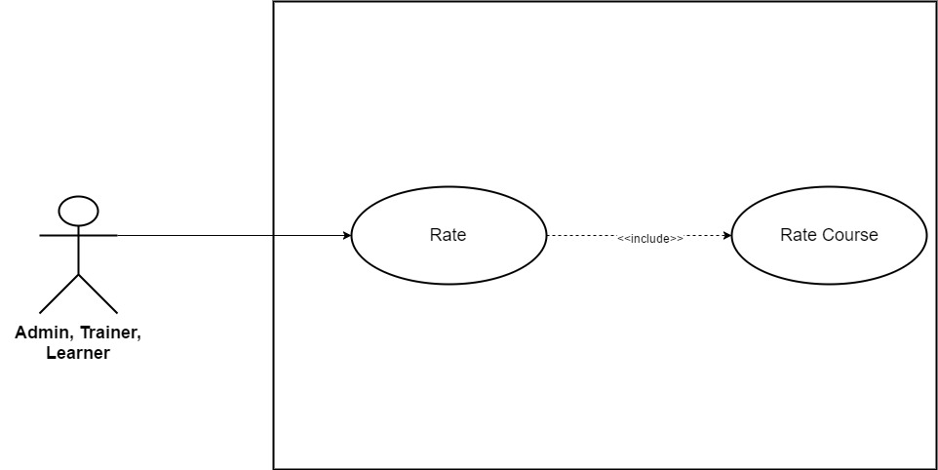

*Figure 3.26: Rate Course*

|  |  |  |  |  |
| --- | --- | --- | --- | --- |
| **Use Case ID** | UC15 | | **Version** | 1.0 |
| **Use Case Name** | Rate Course | | | |
| **Create By** | TruongTN | | **Last Updated** |  |
| **Primary Actor** | Trainer, Learner | | **Secondary Actor** | Administrator |
| **Description** | Rate Course | | | |
| **Pre-Conditions** |  | | | |
| **Post-Conditions** |  | | | |
| **Normal Flows** | | | | |
| **Step** | **Actor** | **Action** | | |
| 1 | Trainer, Learner, Administrator | Scroll down course detail page. | | |
| 2 | System | Display rate section. | | |
| 3 | Trainer, Learner, Administrator | Rate course. | | |
| 4 | System | Update new rate into database. | | |
|  | | | | |
|  | | | | |
| **Priority** | High | | | |
| **Frequency of Use** | High | | | |
| **Business Rules** |  | | | |

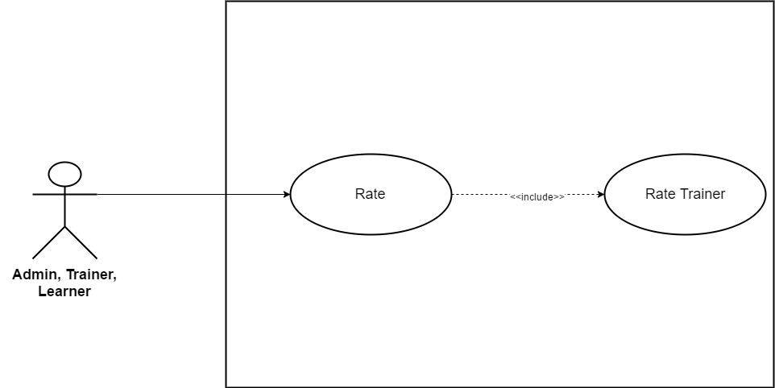

*Figure 3.27: Rate Trainer*

|  |  |  |  |  |
| --- | --- | --- | --- | --- |
| **Use Case ID** | UC16 | | **Version** | 1.0 |
| **Use Case Name** | Rate Trainer | | | |
| **Create By** | TruongTN | | **Last Updated** |  |
| **Primary Actor** | Trainer, Learner | | **Secondary Actor** | Administrator |
| **Description** | Rate Trainer | | | |
| **Pre-Conditions** |  | | | |
| **Post-Conditions** |  | | | |
| **Normal Flows** | | | | |
| **Step** | **Actor** | **Action** | | |
| 1 | Trainer, Learner, Administrator | Click “Trainers” on the menu, the menu stays on the right side of search bar. | | |
| 2 | System | Display trainer list | | |
| 3 | Trainer, Learner, Administrator | Rate trainer. | | |
| 4 | System | Update new rate into database. | | |
|  | | | | |
|  | | | | |
| **Priority** | High | | | |
| **Frequency of Use** | High | | | |
| **Business Rules** |  | | | |

* + 1. **Administrator/Trainer**

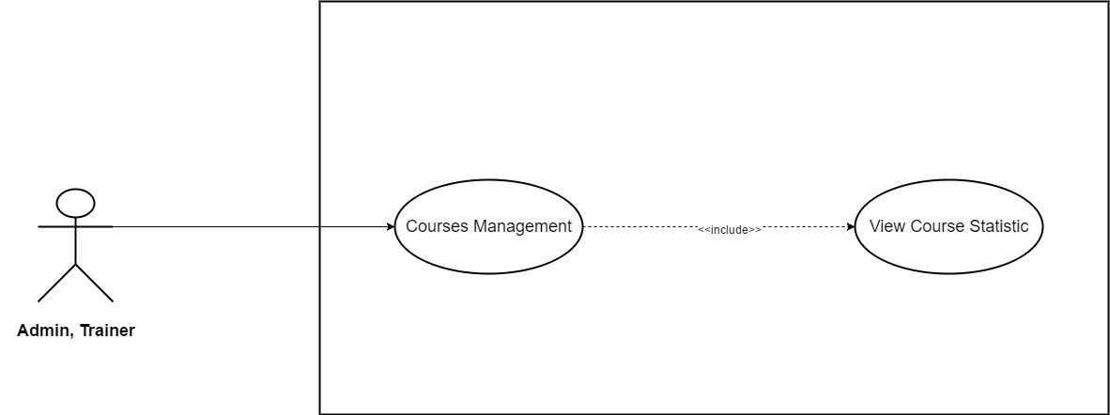

*Figure 3.28: View Course Statistic*

|  |  |  |  |  |
| --- | --- | --- | --- | --- |
| **Use Case ID** | UC17 | | **Version** | 1.0 |
| **Use Case Name** | View Course Statistic | | | |
| **Create By** | TruongTN | | **Last Updated** |  |
| **Primary Actor** | Trainer | | **Secondary Actor** | Administrator |
| **Description** | View Course Statistic | | | |
| **Pre-Conditions** | * User must login first. * Internet connection is required. * User have to be Trainer or Administrator. | | | |
| **Post-Conditions** | * Display view course statistic page. | | | |
| **Normal Flows** | | | | |
| **Step** | **Actor** | **Action** | | |
| 1 | Trainer | Move mouse to Trainer’s name to the right of search bar. | | |
| 2 | System | Display drop-down list. | | |
| 3 | Trainer | Click “Course Management” | | |
| 4 | System | Send Trainer to “Course Management” page | | |
| 5 | Trainer | Click “View Statistic” | | |
| 6 | System | Display “View Statistic” page | | |
| 7 | Trainer | Choose course. | | |
| 8 | System | Display course’s statistic page. | | |
|  | | | | |
| **Priority** | High | | | |
| **Frequency of Use** | High | | | |
| **Business Rules** |  | | | |

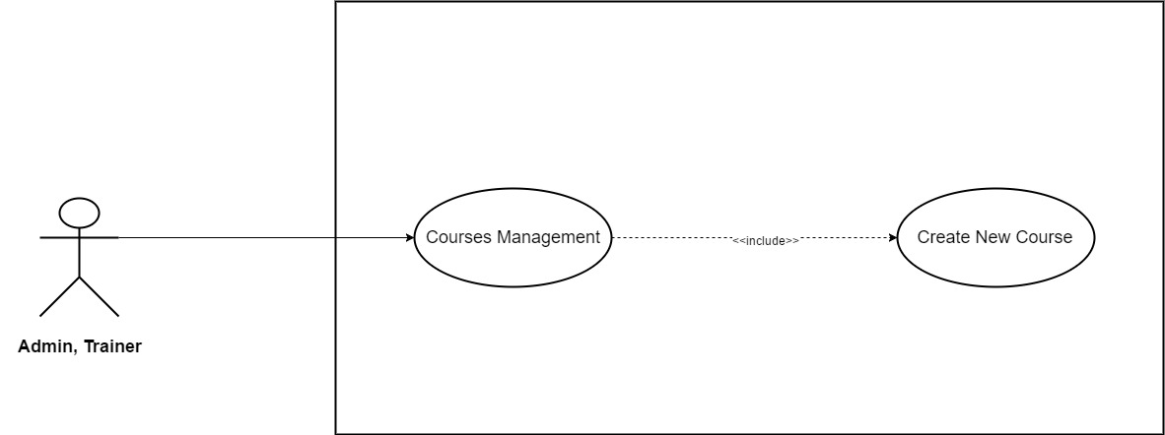

*Figure 3.29: Create New Course*

|  |  |  |  |  |
| --- | --- | --- | --- | --- |
| **Use Case ID** | UC18 | | **Version** | 1.0 |
| **Use Case Name** | Create New Course | | | |
| **Create By** | TruongTN | | **Last Updated** |  |
| **Primary Actor** | Trainer | | **Secondary Actor** | Administrator |
| **Description** | Create new course | | | |
| **Pre-Conditions** | * User must login first. * Internet connection is required. * User have to be Trainer | | | |
| **Post-Conditions** | * New course is saved into system and waited to be approved by administrator. | | | |
| **Normal Flows** | | | | |
| **Step** | **Actor** | **Action** | | |
| 1 | Trainer | Move mouse to Trainer’s name to the right of search bar. | | |
| 2 | System | Display drop-down list. | | |
| 3 | Trainer | Click “Create New Course” | | |
| 4 | System | Send Trainer to “Create New Course” page | | |
| 5 | System | Display “Create New Course” page which contains 5 categories:   * Course Goals * Curriculum * Course Landing Page * Fee * Auto Reply | | |
| 6 | Trainer | Enter course goals information. | | |
| 7 | Trainer | Click “Save” button to save entered information. | | |
| 8 | Trainer | Click “Curriculum”. | | |
| 9 | System | Display “Curriculum” page. | | |
| 10 | Trainer | Click “Upload Lectures and Sections (.xlxs)” to upload. | | |
| 11 | Trainer | Click “Save” button to save. | | |
| 12 | Trainer | Click “Course Landing Page” . | | |
| 13 | System | Display “Course Landing Page” page which contains the following field:   * Course Title * Course Subtitle * Course Description * Language * Level * Category * Primary Taught * Tags * Course Image * Promotional Video | | |
| 14 | Trainer | Enter all the information needed in Course Landing Page. | | |
| 15 | Trainer | Click “Save” button to save. | | |
| 16 | Trainer | Click “Fee” to enter course’s fee. | | |
| 17 | System | Display “Fee” page. | | |
| 18 | Trainer | Choose currency unit. Default: VND | | |
| 19 | Trainer | Enter course’s fee. | | |
| 20 | Trainer | Click “Save” button to save. | | |
| 21 | Trainer | Click “Auto Reply”. | | |
| 22 | System | Display “Auto Reply” page. | | |
| 23 | Trainer | Enter message. | | |
| 24 | Trainer | Click “Save” button to save. | | |
| 25 | Trainer | Click “Submit for review”. | | |
| 26 | System | Submit to the system. | | |
| 27 | Administrator | Approve course. | | |
|  | | | | |
| **Exception** | | | | |
| **EC1** | At step 6, Trainer enter more than 150 character in each text input. | | | |
| **Step** | **Actor** | **Action** | | |
| 6.1 | Trainer | Enter more than 150 character in each text input. | | |
| 6.2 | Trainer | Click “Save” button. | | |
| 6.3 | System | Display message: “Length must be less than 150 character” | | |
| **EC2** | At step 10, Trainer upload wrong file format. | | | |
| **Step** | **Actor** | **Action** | | |
| 10.1 | Trainer | Upload wrong file format. | | |
| 10.2 | Trainer | Click “Save” button. | | |
| 10.3 | System | Display message: “Wrong file format. Required format is .xlxs!” | | |
| **EC3** | At step 14, Course Title is left blank. | | | |
| **Step** | **Actor** | **Action** | | |
| 14.1 | Trainer | Course Title is left blank. | | |
| 14.2 | Trainer | Click “Save” button. | | |
| 14.3 | System | Display message: “Please Enter Course Title!” | | |
| **EC4** | At step 14, Course Subtitle is left blank. | | | |
| **Step** | **Actor** | **Action** | | |
| 14.1 | Trainer | Course Subtitle is left blank. | | |
| 14.2 | Trainer | Click “Save” button. | | |
| 14.3 | System | Display message: “Please Enter Course Subtitle!” | | |
| **EC5** | At step 14, Course Description is left blank. | | | |
| **Step** | **Actor** | **Action** | | |
| 14.1 | Trainer | Course Description is left blank. | | |
| 14.2 | Trainer | Click “Save” button. | | |
| 14.3 | System | Display message: “Please Enter Course Description!” | | |
| **EC6** | At step 14, Trainer doesn’t choose language. | | | |
| **Step** | **Actor** | **Action** | | |
| 14.1 | Trainer | Doesn’t choose language | | |
| 14.2 | Trainer | Click “Save” button. | | |
| 14.3 | System | Display message: “Please Choose Course Language!” | | |
| **EC7** | At step 14, Trainer doesn’t choose category. | | | |
| **Step** | **Actor** | **Action** | | |
| 14.1 | Trainer | Doesn’t choose category | | |
| 14.2 | Trainer | Click “Save” button. | | |
| 14.3 | System | Display message: “Please Choose Course Category!” | | |
| **EC6** | At step 14, Trainer doesn’t upload course image. | | | |
| **Step** | **Actor** | **Action** | | |
| 14.1 | Trainer | Doesn’t upload course image. | | |
| 14.2 | Trainer | Click “Save” button. | | |
| 14.3 | System | Display message: “Please Upload Course Image!” | | |
| **EC7** | At step 14, Trainer enter more than 100 character in course title. | | | |
| **Step** | **Actor** | **Action** | | |
| 14.1 | Trainer | Enter more than 100 characters in course title. | | |
| 14.2 | Trainer | Click “Save” button. | | |
| 14.3 | System | Display message: “Course title length’s must be less than 100 characters” | | |
| **EC8** | At step 14, Trainer enter more than 150 character in course subtitle. | | | |
| **Step** | **Actor** | **Action** | | |
| 14.1 | Trainer | Enter more than 150 characters in course subtitle. | | |
| 14.2 | Trainer | Click “Save” button. | | |
| 14.3 | System | Display message: “Course subtitle’s length must be less than 150 characters” | | |
| **EC9** | At step 14, Trainer enter more than 1000 character in course description. | | | |
| **Step** | **Actor** | **Action** | | |
| 14.1 | Trainer | Enter more than 1000 characters in course description. | | |
| 14.2 | Trainer | Click “Save” button. | | |
| 14.3 | System | Display message: “Course description’s length must be less than 1000 characters” | | |
| **EC8** | At step 14, Trainer upload wrong course image’s dimensions. | | | |
| **Step** | **Actor** | **Action** | | |
| 14.1 | Trainer | Upload wrong course image’s dimensions. | | |
| 14.2 | Trainer | Click “Save” button. | | |
| 14.3 | System | Display message: “Image’s dimensions must be 2048x1152 pixels” | | |
| **EC9** | At step 14, Trainer upload wrong course image’s format. | | | |
| **Step** | **Actor** | **Action** | | |
| 14.1 | Trainer | Upload wrong course image’s format. | | |
| 14.2 | Trainer | Click “Save” button. | | |
| 14.3 | System | Display message: “Image’s format must be one of the following: .jpg, .jpeg, .gif, .bmp or .png!” | | |
| **EC10** | At step 14, Trainer upload video with low quality (less than 360p). | | | |
| **Step** | **Actor** | **Action** | | |
| 14.1 | Trainer | Upload video with low quality (less than 360p) | | |
| 14.2 | Trainer | Click “Save” button. | | |
| 14.3 | System | Display message: “The video’s quality must be at least 360p !” | | |
| **EC11** | At step 14, Trainer upload video with the wrong format. | | | |
| **Step** | **Actor** | **Action** | | |
| 14.1 | Trainer | Upload video with the wrong format. | | |
| 14.2 | Trainer | Click “Save” button. | | |
| 14.3 | System | Display message: “The video’s format must be .mp4!” | | |
| **EC12** | At step 19, Fee is left blank. | | | |
| **Step** | **Actor** | **Action** | | |
| 19.1 | Trainer | Leave fee blank. | | |
| 19.2 | Trainer | Click “Save” button. | | |
| 19.3 | System | Display message: “Please enter course’s fee!” | | |
| **EC13** | At step 23, Trainer enter more than 200 characters in auto reply. | | | |
| **Step** | **Actor** | **Action** | | |
| 23.1 | Trainer | Enter more than 200 characters in auto reply. | | |
| 23.2 | Trainer | Click “Save” button. | | |
| 23.3 | System | Display message: “Auto reply must be less than 200 characters!” | | |
|  |  |  | | |
| **Priority** | High | | | |
| **Frequency of Use** | High | | | |
| **Business Rules** | BR9, BR10, BR11, BR12, BR13, BR14, BR15, BR16, BR17 | | | |

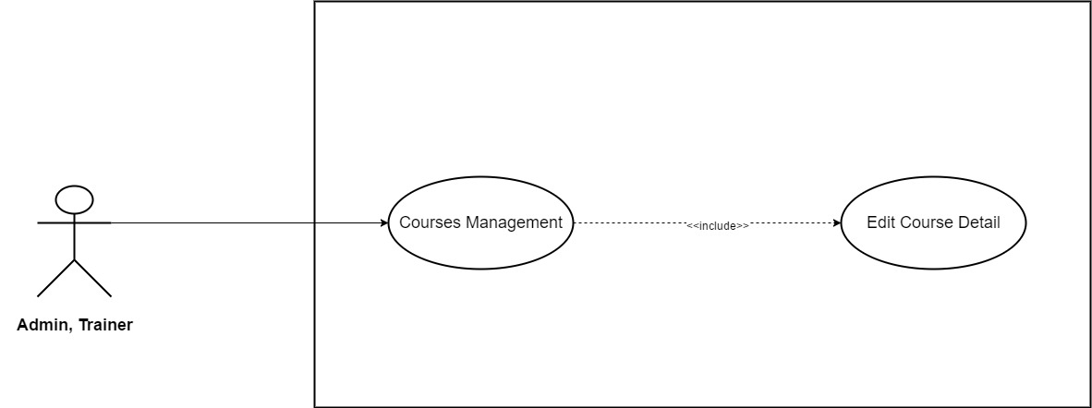

*Figure 3.30: Edit Course Detail*

|  |  |  |  |  |
| --- | --- | --- | --- | --- |
| **Use Case ID** | UC19 | | **Version** | 1.0 |
| **Use Case Name** | Edit Course Detail | | | |
| **Create By** | TruongTN | | **Last Updated** |  |
| **Primary Actor** | Trainer | | **Secondary Actor** | Administrator |
| **Description** | Edit course detail. | | | |
| **Pre-Conditions** | * User must login first. * Internet connection is required. * User have to be Trainer or Administrator. | | | |
| **Post-Conditions** | * New course detail is saved and updated into system. | | | |
| **Normal Flows** | | | | |
| **Step** | **Actor** | **Action** | | |
| 1 | Trainer | Move mouse to Trainer’s name to the right of search bar. | | |
| 2 | System | Display drop-down list. | | |
| 3 | Trainer | Click “Course Management” | | |
| 4 | System | Send Trainer to “Course Management” page | | |
| 5 | Trainer | Click “Edit” button. | | |
| 6 | System | Display edit course page (same as “Create New Course” page” | | |
| 7 | Trainer | Edit course goals information. | | |
| 8 | Trainer | Click “Save” button to save entered information. | | |
| 9 | Trainer | Click “Curriculum”. | | |
| 10 | System | Display “Curriculum” page. | | |
| 11 | Trainer | Click “Upload Lectures and Sections (.xlxs)” to upload. | | |
| 12 | Trainer | Click “Save” button to save. | | |
| 13 | Trainer | Click “Course Landing Page” . | | |
| 14 | System | Display “Course Landing Page” page which contains the following field:   * Course Title * Course Subtitle * Course Description * Language * Level * Category * Primary Taught * Tags * Course Image * Promotional Video | | |
| 15 | Trainer | Edit all the information that they need to change in Course Landing Page. | | |
| 16 | Trainer | Click “Save” button to save. | | |
| 17 | Trainer | Click “Fee” to enter course’s fee. | | |
| 18 | System | Display “Fee” page. | | |
| 19 | Trainer | Choose currency unit. Default: VND | | |
| 20 | Trainer | Edit course’s fee. | | |
| 21 | Trainer | Click “Save” button to save. | | |
| 22 | Trainer | Click “Auto Reply”. | | |
| 23 | System | Display “Auto Reply” page. | | |
| 24 | Trainer | Edit message. | | |
| 25 | Trainer | Click “Save” button to save. | | |
| 26 | Trainer | Click “Submit for review”. | | |
| 27 | System | Submit to the system. | | |
| 28 | Administrator | Approve update. | | |
|  | | | | |
| **Exception** | | | | |
| **EC1** | At step 7, Trainer enter more than 150 character in each text input. | | | |
| **Step** | **Actor** | **Action** | | |
| 7.1 | Trainer | Enter more than 150 character in each text input. | | |
| 7.2 | Trainer | Click “Save” button. | | |
| 7.3 | System | Display message: “Length must be less than 150 character” | | |
| **EC2** | At step 11, Trainer upload wrong file format. | | | |
| **Step** | **Actor** | **Action** | | |
| 11.1 | Trainer | Upload wrong file format. | | |
| 11.2 | Trainer | Click “Save” button. | | |
| 11.3 | System | Display message: “Wrong file format. Required format is .xlxs!” | | |
| **EC3** | At step 15, Course Title is left blank. | | | |
| **Step** | **Actor** | **Action** | | |
| 15.1 | Trainer | Course Title is left blank. | | |
| 15.2 | Trainer | Click “Save” button. | | |
| 15.3 | System | Display message: “Please Enter Course Title!” | | |
| **EC4** | At step 15, Course Subtitle is left blank. | | | |
| **Step** | **Actor** | **Action** | | |
| 15.1 | Trainer | Course Subtitle is left blank. | | |
| 15.2 | Trainer | Click “Save” button. | | |
| 15.3 | System | Display message: “Please Enter Course Subtitle!” | | |
| **EC5** | At step 15, Course Description is left blank. | | | |
| **Step** | **Actor** | **Action** | | |
| 15.1 | Trainer | Course Description is left blank. | | |
| 15.2 | Trainer | Click “Save” button. | | |
| 15.3 | System | Display message: “Please Enter Course Description!” | | |
| **EC6** | At step 13, Trainer doesn’t choose language. | | | |
| **Step** | **Actor** | **Action** | | |
| 15.1 | Trainer | Doesn’t choose language | | |
| 15.2 | Trainer | Click “Save” button. | | |
| 15.3 | System | Display message: “Please Choose Course Language!” | | |
| **EC7** | At step 15, Trainer doesn’t choose category. | | | |
| **Step** | **Actor** | **Action** | | |
| 15.1 | Trainer | Doesn’t choose category | | |
| 15.2 | Trainer | Click “Save” button. | | |
| 15.3 | System | Display message: “Please Choose Course Category!” | | |
| **EC6** | At step 15, Trainer doesn’t upload course image. | | | |
| **Step** | **Actor** | **Action** | | |
| 15.1 | Trainer | Doesn’t upload course image. | | |
| 15.2 | Trainer | Click “Save” button. | | |
| 15.3 | System | Display message: “Please Upload Course Image!” | | |
| **EC7** | At step 15, Trainer enter more than 100 character in course title. | | | |
| **Step** | **Actor** | **Action** | | |
| 15.1 | Trainer | Enter more than 100 characters in course title. | | |
| 15.2 | Trainer | Click “Save” button. | | |
| 15.3 | System | Display message: “Course title length’s must be less than 100 characters” | | |
| **EC8** | At step 15, Trainer enter more than 150 character in course subtitle. | | | |
| **Step** | **Actor** | **Action** | | |
| 15.1 | Trainer | Enter more than 150 characters in course subtitle. | | |
| 15.2 | Trainer | Click “Save” button. | | |
| 15.3 | System | Display message: “Course subtitle’s length must be less than 150 characters” | | |
| **EC9** | At step 15, Trainer enter more than 1000 character in course description. | | | |
| **Step** | **Actor** | **Action** | | |
| 15.1 | Trainer | Enter more than 1000 characters in course description. | | |
| 15.2 | Trainer | Click “Save” button. | | |
| 15.3 | System | Display message: “Course description’s length must be less than 1000 characters” | | |
| **EC8** | At step 15, Trainer upload wrong course image’s dimensions. | | | |
| **Step** | **Actor** | **Action** | | |
| 15.1 | Trainer | Upload wrong course image’s dimensions. | | |
| 15.2 | Trainer | Click “Save” button. | | |
| 15.3 | System | Display message: “Image’s dimensions must be 2048x1152 pixels” | | |
| **EC9** | At step 15, Trainer upload wrong course image’s format. | | | |
| **Step** | **Actor** | **Action** | | |
| 15.1 | Trainer | Upload wrong course image’s format. | | |
| 15.2 | Trainer | Click “Save” button. | | |
| 15.3 | System | Display message: “Image’s format must be one of the following: .jpg, .jpeg, .gif, .bmp or .png!” | | |
| **EC10** | At step 15, Trainer upload video with low quality (less than 360p). | | | |
| **Step** | **Actor** | **Action** | | |
| 15.1 | Trainer | Upload video with low quality (less than 360p) | | |
| 15.2 | Trainer | Click “Save” button. | | |
| 15.3 | System | Display message: “The video’s quality must be at least 360p !” | | |
| **EC11** | At step 15, Trainer upload video with the wrong format. | | | |
| **Step** | **Actor** | **Action** | | |
| 15.1 | Trainer | Upload video with the wrong format. | | |
| 15.2 | Trainer | Click “Save” button. | | |
| 15.3 | System | Display message: “The video’s format must be .mp4!” | | |
| **EC12** | At step 20, Fee is left blank. | | | |
| **Step** | **Actor** | **Action** | | |
| 20.1 | Trainer | Leave fee blank. | | |
| 20.2 | Trainer | Click “Save” button. | | |
| 20.3 | System | Display message: “Please enter course’s fee!” | | |
| **EC13** | At step 24, Trainer enter more than 200 characters in auto reply. | | | |
| **Step** | **Actor** | **Action** | | |
| 24.1 | Trainer | Enter more than 200 characters in auto reply. | | |
| 24.2 | Trainer | Click “Save” button. | | |
| 24.3 | System | Display message: “Auto reply must be less than 200 characters!” | | |
|  |  |  | | |
| **Priority** | High | | | |
| **Frequency of Use** | High | | | |
| **Business Rules** | BR9, BR10, BR11, BR12, BR13, BR14, BR15, BR16, BR17 | | | |

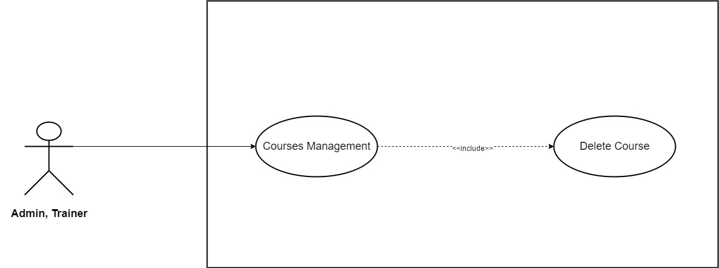

*Figure 3.31: Delete Course*

|  |  |  |  |  |
| --- | --- | --- | --- | --- |
| **Use Case ID** | UC20 | | **Version** | 1.0 |
| **Use Case Name** | Delete Courses | | | |
| **Create By** | TruongTN | | **Last Updated** |  |
| **Primary Actor** | Trainer | | **Secondary Actor** | Administrator |
| **Description** | Delete courses | | | |
| **Pre-Conditions** | * User must login first. * Internet connection is required. * User must be Trainer or Administrator. | | | |
| **Post-Conditions** | * Selected course is removed out of system. | | | |
| **Normal Flows** | | | | |
| **Step** | **Actor** | **Action** | | |
| 1 | Trainer | Move mouse to Trainer’s name to the right of search bar. | | |
| 2 | System | Display drop-down list. | | |
| 3 | Trainer | Click “Course Management” | | |
| 4 | System | Display “Course Management” page . | | |
| 5 | Trainer | Click “Select” button. | | |
| 6 | Trainer | Choose all course that want to delete. | | |
| 7 | Trainer | Click “Delete”. | | |
| 8 | System | Delete all the chosen course out of the system. | | |
| 9 | System | Update and reload “Course Management” page. | | |
|  | | | | |
| **Priority** | High | | | |
| **Frequency of Use** | High | | | |
| **Business Rules** |  | | | |

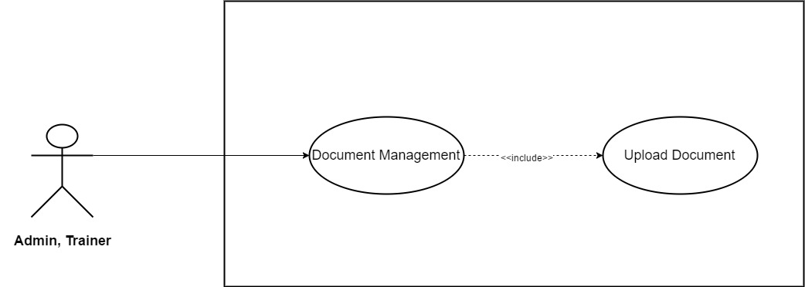

*Figure 3.32: Upload Document*

|  |  |  |  |  |
| --- | --- | --- | --- | --- |
| **Use Case ID** | UC21 | | **Version** | 1.0 |
| **Use Case Name** | Upload Document | | | |
| **Create By** | TruongTN | | **Last Updated** |  |
| **Primary Actor** | Trainer | | **Secondary Actor** | Administrator |
| **Description** | Upload Trainer’s documents | | | |
| **Pre-Conditions** | * User must login first. * Internet connection is required. * User must be Trainer. | | | |
| **Post-Conditions** | * New Document is saved into system and waited to be approved by administrator. | | | |
| **Normal Flows** | | | | |
| **Step** | **Actor** | **Action** | | |
| 1 | Trainer | Move mouse to Trainer’s name to the right of search bar. | | |
| 2 | System | Display drop-down list. | | |
| 3 | Trainer | Click “Documents” | | |
| 4 | System | Send Trainer to Documents’ page | | |
| 5 | System | Display “Documents” page which contain all document that Trainer has uploaded. | | |
| 6 | Trainer | Click “Upload” button. | | |
| 7 | System | Display upload window. | | |
| 8 | Trainer | Choose document file to upload. | | |
| 9 | Trainer | Click “Save” to save documents. “Cancel” to back to Documents’ page. | | |
|  |  |  | | |
| **Exception** | | | | |
| **EC1** | At step 8, *Document* does not meet the format requirement. | | | |
| **Step** | **Actor** | **Action** | | |
| 8.1 | Trainer | User upload wrong document’s format. | | |
| 8.2 | Trainer | Click “Save” button. | | |
| 8.3 | System | Display message: “Document’s format must be .pdf!” | | |
|  |  |  | | |
| **Priority** | High | | | |
| **Frequency of Use** | High | | | |
| **Business Rules** |  | | | |

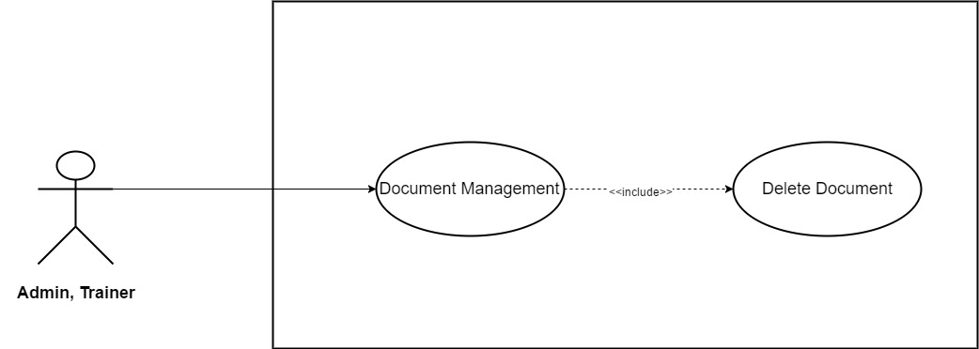

*Figure 3.33: Delete Document*

|  |  |  |  |  |
| --- | --- | --- | --- | --- |
| **Use Case ID** | UC22 | | **Version** | 1.0 |
| **Use Case Name** | Delete Documents | | | |
| **Create By** | TruongTN | | **Last Updated** |  |
| **Primary Actor** | Trainer | | **Secondary Actor** | Administrator |
| **Description** | Delete Document | | | |
| **Pre-Conditions** | * User must login as Trainer first. * Internet connection is required. | | | |
| **Post-Conditions** | * Selected document is removed from the system. | | | |
| **Normal Flows** | | | | |
| **Step** | **Actor** | **Action** | | |
| 1 | Trainer | Move mouse to Trainer’s name to the right of search bar. | | |
| 2 | System | Display drop-down list. | | |
| 3 | Trainer | Click “Documents” | | |
| 4 | System | Send Trainer to Documents’ page | | |
| 5 | System | Display “Documents” page which contain all document that Trainer has uploaded. | | |
| 6 | Trainer | Click “Select”. | | |
| 7 | Trainer | Select all the document that need to be delete. | | |
| 8 | Trainer | Click “Delete”. | | |
| 9 | System | Delete selected document out of the system. | | |
| 10 | System | Update and reload “Documents” page. | | |
|  |  |  | | |
| **Priority** | High | | | |
| **Frequency of Use** | High | | | |
| **Business Rules** |  | | | |

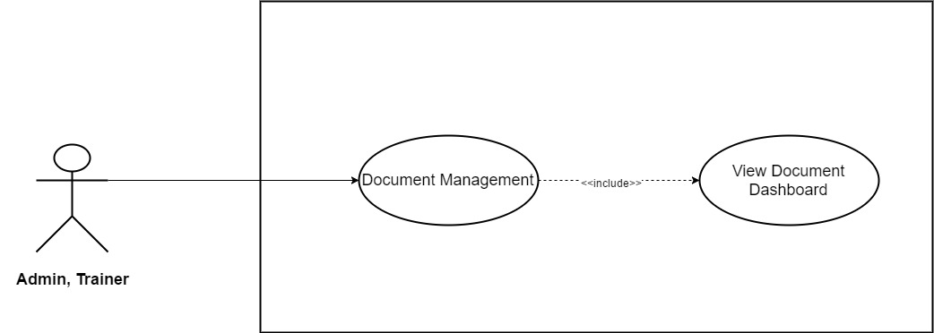

*Figure 3.34: View Document Dashboard*

|  |  |  |  |  |
| --- | --- | --- | --- | --- |
| **Use Case ID** | UC23 | | **Version** | 1.0 |
| **Use Case Name** | View Documents Dashboard | | | |
| **Create By** | TruongTN | | **Last Updated** |  |
| **Primary Actor** | Trainer | | **Secondary Actor** | Administrator |
| **Description** | Access documents dashboard. | | | |
| **Pre-Conditions** | * User must login as Trainer first. * Internet connection is required. | | | |
| **Post-Conditions** | * Display Document page. | | | |
| **Normal Flows** | | | | |
| **Step** | **Actor** | **Action** | | |
| 1 | Trainer | Move mouse to Trainer’s name to the right of search bar. | | |
| 2 | System | Display drop-down list. | | |
| 3 | Trainer | Click “Documents” | | |
| 4 | System | Send Trainer to Documents’ page | | |
| 5 | System | Display “Documents” page which contain all document that Trainer has uploaded. | | |
|  |  |  | | |
| **Priority** | High | | | |
| **Frequency of Use** | High | | | |
| **Business Rules** |  | | | |

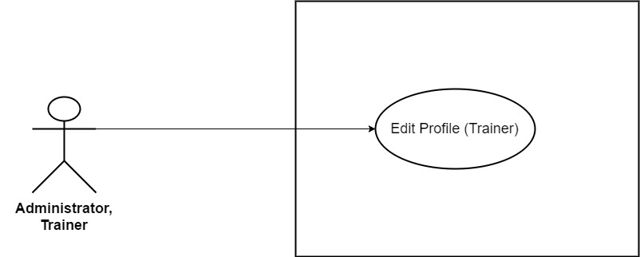

*Figure 3.35: Edit Profile (Trainer)*

|  |  |  |  |  |
| --- | --- | --- | --- | --- |
| **Use Case ID** | UC24 | | **Version** | 1.0 |
| **Use Case Name** | Edit Profile (*Trainer*) | | | |
| **Create By** | TruongTN | | **Last Updated** |  |
| **Primary Actor** | Trainer | | **Secondary Actor** | Administrator |
| **Description** | Edit account’s information for *Trainer* | | | |
| **Pre-Conditions** | * User must login first. * Internet connection is required. | | | |
| **Post-Conditions** | * New account information is saved and updated into system. | | | |
| **Normal Flows** | | | | |
| **Step** | **Actor** | **Action** | | |
| 1 | Trainer | Move mouse to Trainer’s name to the right of search bar. | | |
| 2 | System |  | | |
| 3 | Trainer |  | | |
| 4 | System |  | | |
| 5 | System | Display drop-down list. | | |
| 6 | Trainer | Click “My Profile” | | |
| 7 | Trainer | Send Trainer to “My Profile” page | | |
| 8 | System | Update information into system’s Database. | | |
| 9 | System | Display “My Profile” page with updated information. | | |
|  | | | | |
| **Exception** | | | | |
| **EC1** | At step 6, Trainer remove all required field and leave it blank. | | | |
| **Step** | **Actor** | **Action** | | |
| 6.1 | Trainer | Remove and leave all required field blank. | | |
| 6.2 | Trainer | Click “Save” button. | | |
| 6.3 | System | Display message: “Please Fill In All Required Field!” | | |
| **EC2** | At step 6, Trainer only remove Trainer Name and leave it blank. | | | |
| **Step** | **Actor** | **Action** | | |
| 6.1 | Trainer | Remove and leave Trainer Name blank. | | |
| 6.2 | Trainer | Click “Save” button. | | |
| 6.3 | System | Display message: “Please Enter Trainer Name!” | | |
| **EC3** | At step 6, only *Fields* is not selected. | | | |
| **Step** | **Actor** | **Action** | | |
| 6.1 | Trainer | Do not select *Fields.* | | |
| 6.2 | Trainer | Click “Save” button. | | |
| 6.3 | System | Display message: “Please Select Fields!” | | |
| **EC4** | At step 6, Trainer remove and leave *Contact* blank. | | | |
| **Step** | **Actor** | **Action** | | |
| 6.1 | Trainer | Remove and leave *Contact* field blank. | | |
| 6.2 | Trainer | Click “Save” button. | | |
| 6.3 | System | Display message: “Please Enter Password!” | | |
| **EC5** | At step 6, Trainer only remove and leave *Address* blank. | | | |
| **Step** | **Actor** | **Action** | | |
| 6.1 | Trainer | Remove and leave *Address* blank. | | |
| 6.2 | Trainer | Click “Save” button. | | |
| 6.3 | System | Display message: “Please Enter Address!” | | |
| **EC6** | At step 6, *Introduction*’s length > 200 character. | | | |
| **Step** | **Actor** | **Action** | | |
| 6.1 | Trainer | Enter more than 200 character in *Introduction* field. | | |
| 6.2 | Trainer | Click “Save” button. | | |
| 6.3 | System | Display message: “Length must be < 200” | | |
|  |  |  | | |
| **Priority** | High | | | |
| **Frequency of Use** | High | | | |
| **Business Rules** | BR1 | | | |

* + 1. **Administrator/Learner/Trainer/Guest**

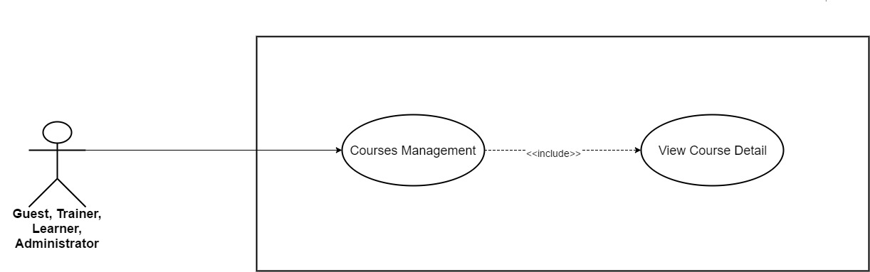

*Figure 3.36: View Course Detail*

|  |  |  |  |  |
| --- | --- | --- | --- | --- |
| **Use Case ID** | UC25 | | **Version** | 1.0 |
| **Use Case Name** | View Course Detail | | | |
| **Create By** | TruongTN | | **Last Updated** |  |
| **Primary Actor** | Guest, Trainer, Learner | | **Secondary Actor** | Administrator |
| **Description** | View Course Detail | | | |
| **Pre-Conditions** |  | | | |
| **Post-Conditions** |  | | | |
| **Normal Flows** | | | | |
| **Step** | **Actor** | **Action** | | |
| 1 | Guest, Trainer, Learner, Administrator | Go to course list that display in homepage or select course list by category. | | |
| 2 | Guest, Trainer, Learner, Administrator | Choose the course that they want to see detail. | | |
| 3 | System | Display course detail page. | | |
|  | | | | |
|  | | | | |
| **Priority** | High | | | |
| **Frequency of Use** | High | | | |
| **Business Rules** |  | | | |

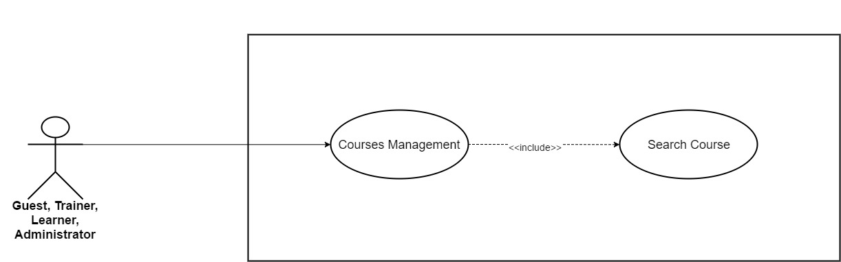

*Figure 3.37: Search Course*

|  |  |  |  |  |
| --- | --- | --- | --- | --- |
| **Use Case ID** | UC26 | | **Version** | 1.0 |
| **Use Case Name** | Search Course | | | |
| **Create By** | TruongTN | | **Last Updated** |  |
| **Primary Actor** | Guest, Trainer, Learner | | **Secondary Actor** | Administrator |
| **Description** | Search Course | | | |
| **Pre-Conditions** |  | | | |
| **Post-Conditions** |  | | | |
| **Normal Flows** | | | | |
| **Step** | **Actor** | **Action** | | |
| 1 | Guest, Trainer, Learner, Administrator | Fill in course name that needed to be search in search bar. | | |
| 2 | System | Display all match result. | | |
|  | | | | |
|  | | | | |
| **Priority** | High | | | |
| **Frequency of Use** | High | | | |
| **Business Rules** |  | | | |

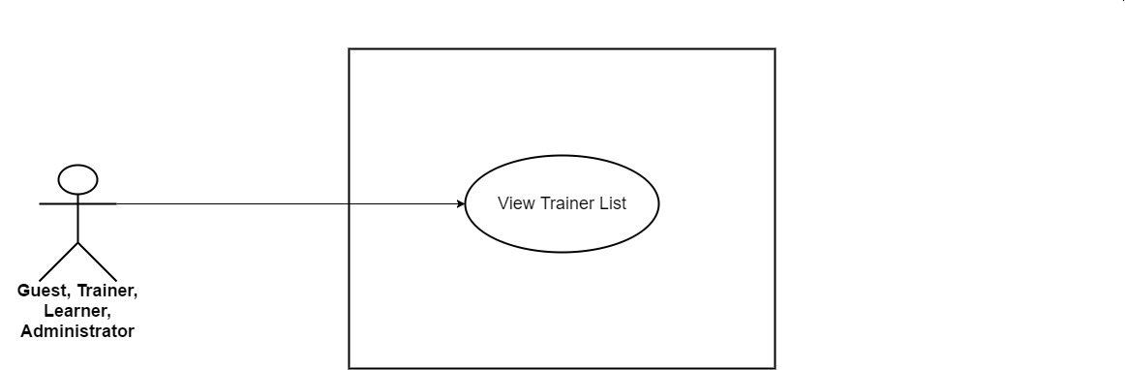

*Figure 3.38: View Trainer List*

|  |  |  |  |  |
| --- | --- | --- | --- | --- |
| **Use Case ID** | UC27 | | **Version** | 1.0 |
| **Use Case Name** | View Trainer List | | | |
| **Create By** | TruongTN | | **Last Updated** |  |
| **Primary Actor** | Trainer,Learner,Guest | | **Secondary Actor** | Administrator |
| **Description** | View all trainer in the system. | | | |
| **Pre-Conditions** | * User must login first. * Internet connection is required. | | | |
| **Post-Conditions** | * Display trainer list. | | | |
| **Normal Flows** | | | | |
| **Step** | **Actor** | **Action** | | |
| 1 | Trainer/Learner | Click “Trainer” in the header to the left of search bar. | | |
| 2 | System | Display trainer list. | | |
|  |  |  | | |
| **Priority** | High | | | |
| **Frequency of Use** | High | | | |
| **Business Rules** |  | | | |

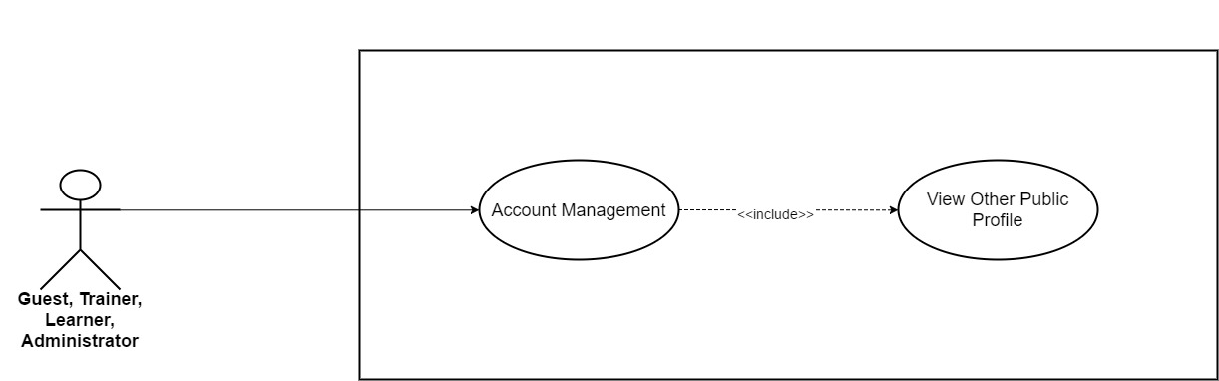

*Figure 3.39: View Other Public Profile*

|  |  |  |  |  |
| --- | --- | --- | --- | --- |
| **Use Case ID** | UC28 | | **Version** | 1.0 |
| **Use Case Name** | View Other Public Profile | | | |
| **Create By** | TruongTN | | **Last Updated** |  |
| **Primary Actor** | Guest, Trainer, Learner | | **Secondary Actor** | Administrator |
| **Description** | View Other Public Profile | | | |
| **Pre-Conditions** |  | | | |
| **Post-Conditions** |  | | | |
| **Normal Flows** | | | | |
| **Step** | **Actor** | **Action** | | |
| 1 | Guest, Trainer, Learner, Administrator | Click username that they want to see public profile. | | |
| 2 | System | Display public profile page. | | |
|  | | | | |
|  | | | | |
| **Priority** | High | | | |
| **Frequency of Use** | High | | | |
| **Business Rules** |  | | | |

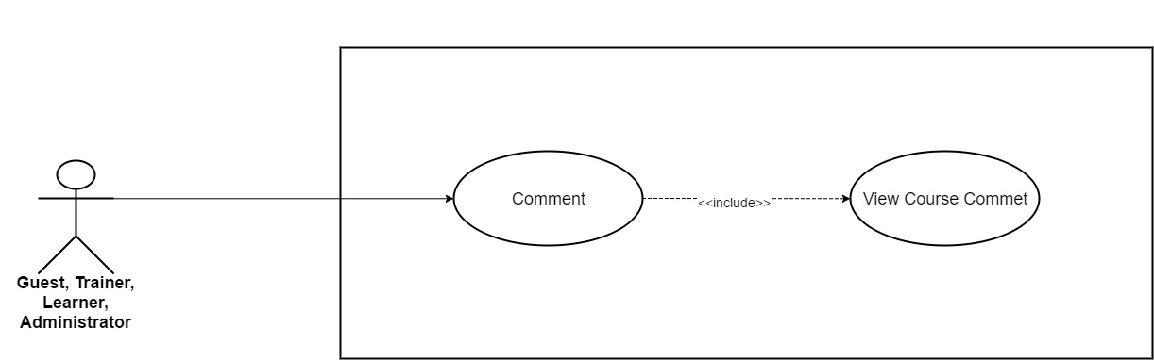

*Figure 3.40: View Course Comment*

|  |  |  |  |  |
| --- | --- | --- | --- | --- |
| **Use Case ID** | UC29 | | **Version** | 1.0 |
| **Use Case Name** | View Course Comment | | | |
| **Create By** | TruongTN | | **Last Updated** |  |
| **Primary Actor** | Guest, Trainer, Learner | | **Secondary Actor** | Administrator |
| **Description** | View Course Comment | | | |
| **Pre-Conditions** |  | | | |
| **Post-Conditions** |  | | | |
| **Normal Flows** | | | | |
| **Step** | **Actor** | **Action** | | |
| 1 | Guest, Trainer, Learner, Administrator | In course detail, scroll down till the end of the page. | | |
| 2 | System | Display comment section page. | | |
|  | | | | |
|  | | | | |
| **Priority** | High | | | |
| **Frequency of Use** | High | | | |
| **Business Rules** |  | | | |

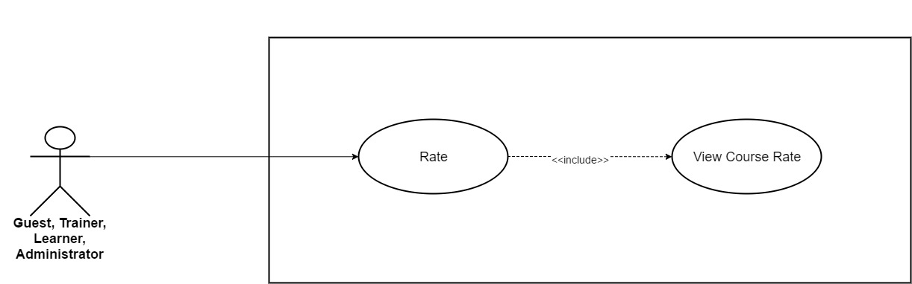

*Figure 3.41: View Course Rate*

|  |  |  |  |  |
| --- | --- | --- | --- | --- |
| **Use Case ID** | UC30 | | **Version** | 1.0 |
| **Use Case Name** | View course rate | | | |
| **Create By** | TruongTN | | **Last Updated** |  |
| **Primary Actor** | Guest, Trainer, Learner | | **Secondary Actor** | Administrator |
| **Description** | View Course rate. | | | |
| **Pre-Conditions** |  | | | |
| **Post-Conditions** |  | | | |
| **Normal Flows** | | | | |
| **Step** | **Actor** | **Action** | | |
| 1 | Guest, Trainer, Learner, Administrator | Open course. | | |
| 2 | System | Display course detail page. Rate course is under course’s name. | | |
|  | | | | |
|  | | | | |
| **Priority** | High | | | |
| **Frequency of Use** | High | | | |
| **Business Rules** |  | | | |

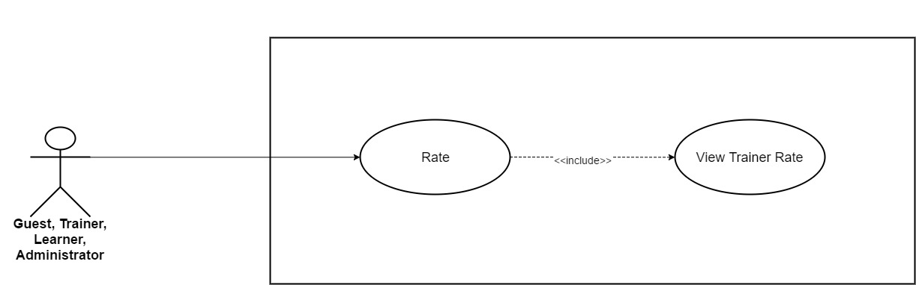

*Figure 3.42: View Trainer Rate*

|  |  |  |  |  |
| --- | --- | --- | --- | --- |
| **Use Case ID** | UC31 | | **Version** | 1.0 |
| **Use Case Name** | View Trainer Rate | | | |
| **Create By** | TruongTN | | **Last Updated** |  |
| **Primary Actor** | Trainer, Learner, Guest | | **Secondary Actor** | Administrator |
| **Description** | View trainer’s rate. | | | |
| **Pre-Conditions** |  | | | |
| **Post-Conditions** |  | | | |
| **Normal Flows** | | | | |
| **Step** | **Actor** | **Action** | | |
| 1 | Trainer, Learner, Administrator | Click “Trainers” on the menu, the menu stays on the right side of search bar. | | |
| 2 | System | Display trainer list. Rate is under trainer’s picture. | | |
|  | | | | |
|  | | | | |
| **Priority** | High | | | |
| **Frequency of Use** | High | | | |
| **Business Rules** |  | | | |

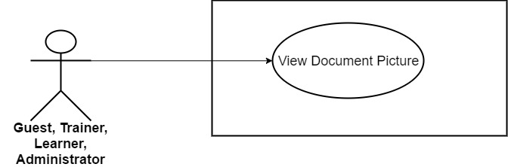

*Figure 3.43: View Document Picture*

|  |  |  |  |  |
| --- | --- | --- | --- | --- |
| **Use Case ID** | UC32 | | **Version** | 1.0 |
| **Use Case Name** | View Document Picture | | | |
| **Create By** | TruongTN | | **Last Updated** |  |
| **Primary Actor** | Trainer, Learner | | **Secondary Actor** | Administrator |
| **Description** | View Document Picture | | | |
| **Pre-Conditions** |  | | | |
| **Post-Conditions** |  | | | |
| **Normal Flows** | | | | |
| **Step** | **Actor** | **Action** | | |
| 1 | Trainer, Learner | On public profile page or document page, click document. | | |
| 2 | System | Display document picture. | | |
|  | | | | |
|  | | | | |
| **Priority** | High | | | |
| **Frequency of Use** | High | | | |
| **Business Rules** |  | | | |

* + 1. **Administrator**

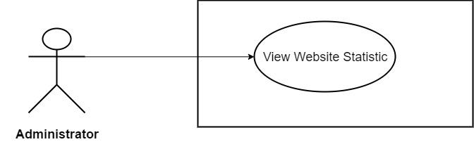

*Figure 3.44: View Website Statistic*

|  |  |  |  |  |
| --- | --- | --- | --- | --- |
| **Use Case ID** | UC33 | | **Version** | 1.0 |
| **Use Case Name** | View Website Statistic | | | |
| **Create By** | TruongTN | | **Last Updated** |  |
| **Primary Actor** | Administrator | | **Secondary Actor** |  |
| **Description** | View website statistic | | | |
| **Pre-Conditions** |  | | | |
| **Post-Conditions** |  | | | |
| **Normal Flows** | | | | |
| **Step** | **Actor** | **Action** | | |
| 1 | Administrator | Click “Go to Dashboard” in the menu. | | |
| 2 | System | Send Admin to Admin’s Dashboard. | | |
| 3 | System | Display “Home” page which contain website’s statistic. | | |
|  | | | | |
| **Priority** | High | | | |
| **Frequency of Use** | High | | | |
| **Business Rules** |  | | | |

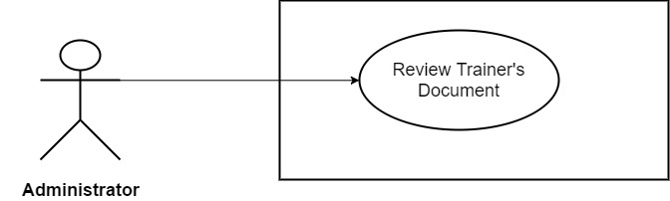

*Figure 3.45: Review Trainer’s Document*

|  |  |  |  |  |
| --- | --- | --- | --- | --- |
| **Use Case ID** | UC34 | | **Version** | 1.0 |
| **Use Case Name** | Review Trainer’s Document | | | |
| **Create By** | TruongTN | | **Last Updated** |  |
| **Primary Actor** | Administrator | | **Secondary Actor** |  |
| **Description** | Review Trainer’s Document | | | |
| **Pre-Conditions** |  | | | |
| **Post-Conditions** |  | | | |
| **Normal Flows** | | | | |
| **Step** | **Actor** | **Action** | | |
| 1 | Administrator | Click “Go to Dashboard” in the menu. | | |
| 2 | System | Send Admin to Admin’s Dashboard. | | |
| 3 | Administrator | Click “Document”. | | |
| 4 | System | Display trainers management page. | | |
| 5 | Administrator | Click “Accept” to accept trainer’s document or Click “Reject” to reject trainer’s document. | | |
| 6 | System | Save new change into database. | | |
|  | | | | |
| **Priority** | High | | | |
| **Frequency of Use** | High | | | |
| **Business Rules** |  | | | |

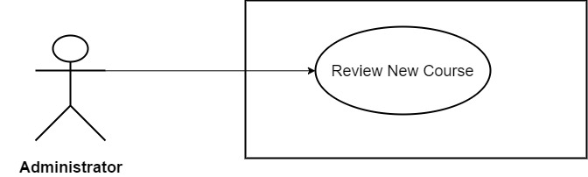

*Figure 3.46: Review New Course*

|  |  |  |  |  |
| --- | --- | --- | --- | --- |
| **Use Case ID** | UC35 | | **Version** | 1.0 |
| **Use Case Name** | Review New Course | | | |
| **Create By** | TruongTN | | **Last Updated** |  |
| **Primary Actor** | Administrator | | **Secondary Actor** |  |
| **Description** | Review New Course | | | |
| **Pre-Conditions** |  | | | |
| **Post-Conditions** |  | | | |
| **Normal Flows** | | | | |
| **Step** | **Actor** | **Action** | | |
| 1 | Administrator | Click “Go to Dashboard” in the menu. | | |
| 2 | System | Send Admin to Admin’s Dashboard. | | |
| 3 | Administrator | Click “Courses”. | | |
| 4 | System | Display courses management page. | | |
| 5 | Administrator | Click “Accept” to accept course or Click “Reject” to reject course. | | |
| 6 | System | Save new change into database. | | |
|  | | | | |
| **Priority** | High | | | |
| **Frequency of Use** | High | | | |
| **Business Rules** |  | | | |

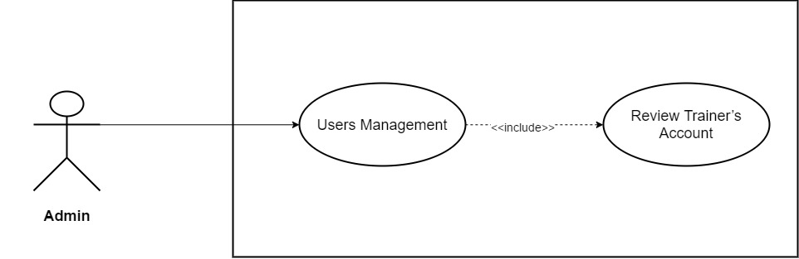

*Figure 3.47: Review Trainer’s Account*

|  |  |  |  |  |
| --- | --- | --- | --- | --- |
| **Use Case ID** | UC36 | | **Version** | 1.0 |
| **Use Case Name** | Review Trainer’s Account | | | |
| **Create By** | TruongTN | | **Last Updated** |  |
| **Primary Actor** | Administrator | | **Secondary Actor** |  |
| **Description** | Review Trainer’s Account | | | |
| **Pre-Conditions** |  | | | |
| **Post-Conditions** |  | | | |
| **Normal Flows** | | | | |
| **Step** | **Actor** | **Action** | | |
| 1 | Administrator | Click “Go to Dashboard” in the menu. | | |
| 2 | System | Send Admin to Admin’s Dashboard. | | |
| 3 | Administrator | Click “Users”. | | |
| 4 | System | Drop down list include “Learners” and “Trainers” | | |
| 5 | Administrator | Click “Trainers” | | |
| 6 | System | Display trainers management page. | | |
| 7 | Administrator | Click “Accept” to accept new trainer sign up or Click “Reject” to reject new trainer sign up. | | |
| 8 | System | Save new change into database. | | |
|  | | | | |
| **Priority** | High | | | |
| **Frequency of Use** | High | | | |
| **Business Rules** |  | | | |

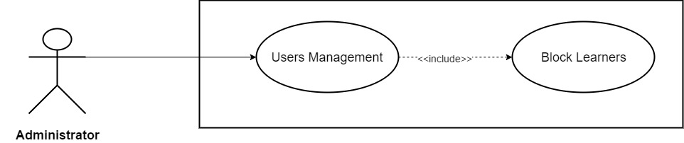

*Figure 3.48: Block Learners*

|  |  |  |  |  |
| --- | --- | --- | --- | --- |
| **Use Case ID** | UC37 | | **Version** | 1.0 |
| **Use Case Name** | Block Learners | | | |
| **Create By** | TruongTN | | **Last Updated** |  |
| **Primary Actor** | Administrator | | **Secondary Actor** |  |
| **Description** | Block Learners | | | |
| **Pre-Conditions** |  | | | |
| **Post-Conditions** |  | | | |
| **Normal Flows** | | | | |
| **Step** | **Actor** | **Action** | | |
| 1 | Administrator | Click “Go to Dashboard” in the menu. | | |
| 2 | System | Send Admin to Admin’s Dashboard. | | |
| 3 | Administrator | Click “Users”. | | |
| 4 | System | Drop down list include “Learners” and “Trainers” | | |
| 5 | Administrator | Click “Learners” | | |
| 6 | System | Display Learners management page. | | |
| 7 | Administrator | Click “Block” next to learner’s name that needed to be edit. | | |
| 8 | System | Display dialog box “Do you want to block this user?” “Yes” “No” | | |
| 9 | Administrator | Click “Yes” to block or “No” to cancel. | | |
| 10 | System | Block account from system. | | |
|  |  |  | | |
|  | | | | |
|  | | | | |
| **Priority** | High | | | |
| **Frequency of Use** | High | | | |
| **Business Rules** |  | | | |

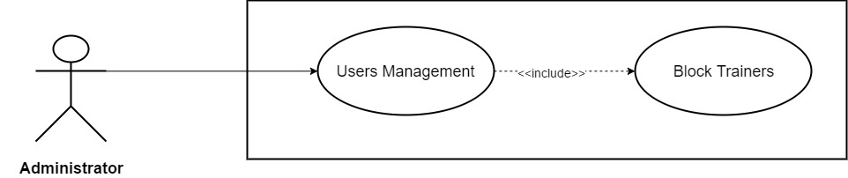

*Figure 3.49: Block Trainers*

|  |  |  |  |  |
| --- | --- | --- | --- | --- |
| **Use Case ID** | UC38 | | **Version** | 1.0 |
| **Use Case Name** | Block Trainers | | | |
| **Create By** | TruongTN | | **Last Updated** |  |
| **Primary Actor** | Administrator | | **Secondary Actor** |  |
| **Description** | Block Trainers | | | |
| **Pre-Conditions** |  | | | |
| **Post-Conditions** |  | | | |
| **Normal Flows** | | | | |
| **Step** | **Actor** | **Action** | | |
| 1 | Administrator | Click “Go to Dashboard” in the menu. | | |
| 2 | System | Send Admin to Admin’s Dashboard. | | |
| 3 | Administrator | Click “Users”. | | |
| 4 | System | Drop down list include “Learners” and “Trainers” | | |
| 5 | Administrator | Click “Trainers” | | |
| 6 | System | Display trainers management page. | | |
| 7 | Administrator | Click “Block” next to trainer’s name that needed to be edit. | | |
| 8 | System | Display dialog box “Do you want to block this user?” “Yes” “No” | | |
| 9 | Administrator | Click “Yes” to block or “No” to cancel. | | |
| 10 | System | Block account from system. | | |
|  |  |  | | |
|  | | | | |
|  | | | | |
| **Priority** | High | | | |
| **Frequency of Use** | High | | | |
| **Business Rules** |  | | | |

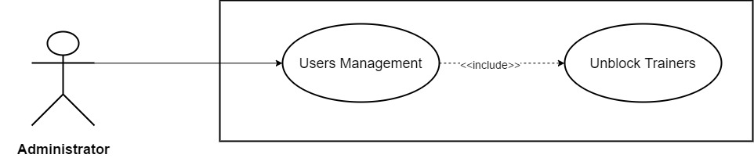

*Figure 3.50: Unblock Trainers*

|  |  |  |  |  |
| --- | --- | --- | --- | --- |
| **Use Case ID** | UC39 | | **Version** | 1.0 |
| **Use Case Name** | Unblock Trainers | | | |
| **Create By** | TruongTN | | **Last Updated** |  |
| **Primary Actor** | Administrator | | **Secondary Actor** |  |
| **Description** | Unblock Trainers | | | |
| **Pre-Conditions** |  | | | |
| **Post-Conditions** |  | | | |
| **Normal Flows** | | | | |
| **Step** | **Actor** | **Action** | | |
| 1 | Administrator | Click “Go to Dashboard” in the menu. | | |
| 2 | System | Send Admin to Admin’s Dashboard. | | |
| 3 | Administrator | Click “Users”. | | |
| 4 | System | Drop down list include “Learners” and “Trainers” | | |
| 5 | Administrator | Click “Trainers” | | |
| 6 | System | Display trainers management page. | | |
| 7 | Administrator | In “Blocked Trainer” table, click “Unblock” next to trainer’s name that needed to be edit. | | |
| 8 | System | Display dialog box “Do you want to unblock this user?” “Yes” “No” | | |
| 9 | Administrator | Click “Yes” to unblock or “No” to cancel. | | |
| 10 | System | Unblock account from system. | | |
|  |  |  | | |
|  | | | | |
|  | | | | |
| **Priority** | High | | | |
| **Frequency of Use** | High | | | |
| **Business Rules** |  | | | |

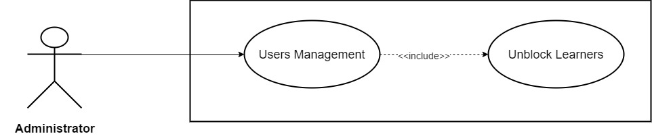

*Figure 3.51: Unblock Learners*

|  |  |  |  |  |
| --- | --- | --- | --- | --- |
| **Use Case ID** | UC40 | | **Version** | 1.0 |
| **Use Case Name** | Unblock Learner | | | |
| **Create By** | TruongTN | | **Last Updated** |  |
| **Primary Actor** | Administrator | | **Secondary Actor** |  |
| **Description** | Unblock Learner | | | |
| **Pre-Conditions** |  | | | |
| **Post-Conditions** |  | | | |
| **Normal Flows** | | | | |
| **Step** | **Actor** | **Action** | | |
| 1 | Administrator | Click “Go to Dashboard” in the menu. | | |
| 2 | System | Send Admin to Admin’s Dashboard. | | |
| 3 | Administrator | Click “Users”. | | |
| 4 | System | Drop down list include “Learners” and “Trainers” | | |
| 5 | Administrator | Click “Learners” | | |
| 6 | System | Display learner management page. | | |
| 7 | Administrator | In “Blocked Learners” table, click “Unblock” next to learner’s name that needed to be edit. | | |
| 8 | System | Display dialog box “Do you want to unblock this user?” “Yes” “No” | | |
| 9 | Administrator | Click “Yes” to unblock or “No” to cancel. | | |
| 10 | System | Unblock account from system. | | |
|  |  |  | | |
|  | | | | |
|  | | | | |
| **Priority** | High | | | |
| **Frequency of Use** | High | | | |
| **Business Rules** |  | | | |

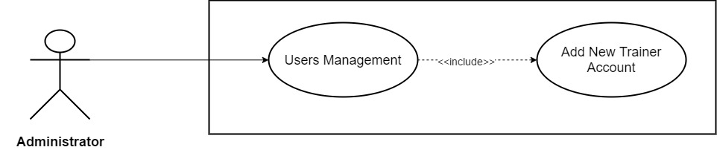

*Figure 3.52: Add New Trainer Account*

|  |  |  |  |  |  |  |
| --- | --- | --- | --- | --- | --- | --- |
| **Use Case ID** | UC41 | | | | **Version** | 1.0 |
| **Use Case Name** | Add New Trainer Account | | | | | |
| **Create By** | TruongTN | | | | **Last Updated** |  |
| **Primary Actor** | Administrator | | | | **Secondary Actor** |  |
| **Description** | Add New Trainer Account | | | | | |
| **Pre-Conditions** |  | | | | | |
| **Post-Conditions** |  | | | | | |
| **Normal Flows** | | | | | | |
| **Step** | **Actor** | | | **Action** | | |
| 1 | Administrator | | | Click “Go to Dashboard” in the menu. | | |
| 2 | System | | | Send Admin to Admin’s Dashboard. | | |
| 3 | Administrator | | | Click “Users”. | | |
| 4 | System | | | Drop down list include “Learners” and “Trainers” | | |
| 5 | Administrator | | | Click “Trainers” | | |
| 6 | System | | | Display trainers management page. | | |
| 7 | Administrator | | | Enter “Email” and “Password” | | |
| 8 | Administrator | | | Click “Create” to save or “Cancel” to cancel. | | |
| 9 | System | | | Save new account into system | | |
|  |  | | |  | | |
| **Exception** | | | | | | |
| **EC1** | | At step 7, all fields are blank. | | | | |
| **Step** | | **Actor** | **Action** | | | |
| 7.1 | | Administrator | Leave all required field blank. | | | |
| 7.2 | | Administrator | Click “Create” button. | | | |
| 7.3 | | System | Display message: “Please Enter Email and Password!” | | | |
| **EC2** | | At step 7, *Email* is left blank. | | | | |
| **Step** | | **Actor** | **Action** | | | |
| 7.1 | | Administrator | Leave *Email* field blank. | | | |
| 7.2 | | Administrator | Click “Create” button. | | | |
| 7.3 | | System | Display message: “Please Enter Email!” | | | |
| **EC3** | | At step 7, only *Password* is left blank. | | | | |
| **Step** | | **Actor** | **Action** | | | |
| 7.1 | | Administrator | Leave *Password* field blank. | | | |
| 7.2 | | Administrator | Click “Create” button. | | | |
| 7.3 | | System | Display message: “Create!” | | | |
| **EC4** | | At step 7, *Email* is invalid. (Incorrect *Email* format: abc@xyz) | | | | |
| **Step** | | **Actor** | **Action** | | | |
| 7.1 | | Administrator | Enter invalid *Email*. | | | |
| 7.2 | | Administrator | Click “Create” button. | | | |
| 7.3 | | System | Display message: “Invalid Email!” | | | |
| **EC5** | | At step 7, *Password*’s length < 8. | | | | |
| **Step** | | **Actor** | **Action** | | | |
| 7.1 | | Administrator | Enter *Password* less than 8 characters. | | | |
| 7.2 | | Administrator | Click “Create” button. | | | |
| 7.3 | | System | Display message: “Password must contains at least one upper case, one number, one special character and length must be >8!” | | | |
| **EC6** | | At step 7, *Password* does not contain any upper case. | | | | |
| **Step** | | **Actor** | **Action** | | | |
| 7.1 | | Administrator | Enter *Password* that does not contain any upper case. | | | |
| 7.2 | | Administrator | Click “Create” button. | | | |
| 7.3 | | System | Display message: “Password must contains at least one upper case, one number, one special character and length must be >8!” | | | |
| **EC7** | | At step 7, *Password* does not contain any number. | | | | |
| **Step** | | **Actor** | **Action** | | | |
| 7.1 | | Administrator | Enter *Password* that does not contain any number. | | | |
| 7.2 | | Administrator | Click “Create” button. | | | |
| 7.3 | | System | Display message: “Password must contains at least one upper case, one number, one special character and length must be >8!” | | | |
| **EC8** | | At step 7, *Password* does not contain at least one special character. | | | | |
| **Step** | | **Actor** | **Action** | | | |
| 7.1 | | Administrator | Enter *Password* does not contain at least one special character. | | | |
| 7.2 | | Administrator | Click “Create” button. | | | |
| 7.3 | | System | Display message: “Password must contains at least one upper case, one number, one special character and length must be >8!” | | | |
| **EC9** | | At step 7, Email address is already registered. | | | | |
| **Step** | | **Actor** | **Action** | | | |
| 7.1 | | Administrator | Enter email address is already registered. | | | |
| 7.2 | | Administrator | Click “Create” button. | | | |
| 7.3 | | System | Display message: “The email address you have entered is already registered.” | | | |
|  | | | | | | |
|  | | | | | | |
| **Priority** | High | | | | | |
| **Frequency of Use** | High | | | | | |
| **Business Rules** |  | | | | | |

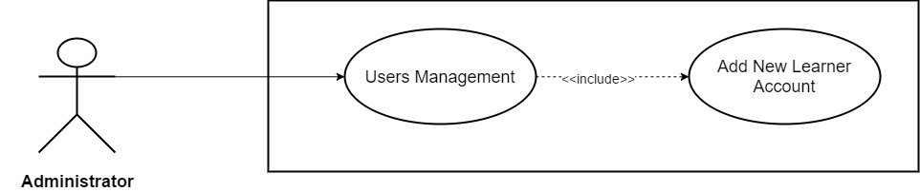

*Figure 3.53: Add New Learner Account*

|  |  |  |  |  |  |  |
| --- | --- | --- | --- | --- | --- | --- |
| **Use Case ID** | UC42 | | | | **Version** | 1.0 |
| **Use Case Name** | Add New Learner Account | | | | | |
| **Create By** | TruongTN | | | | **Last Updated** |  |
| **Primary Actor** | Administrator | | | | **Secondary Actor** |  |
| **Description** | Add New Learner Account | | | | | |
| **Pre-Conditions** |  | | | | | |
| **Post-Conditions** |  | | | | | |
| **Normal Flows** | | | | | | |
| **Step** | **Actor** | | | **Action** | | |
| 1 | Administrator | | | Click “Go to Dashboard” in the menu. | | |
| 2 | System | | | Send Admin to Admin’s Dashboard. | | |
| 3 | Administrator | | | Click “Users”. | | |
| 4 | System | | | Drop down list include “Learners” and “Trainers” | | |
| 5 | Administrator | | | Click “Learners” | | |
| 6 | System | | | Display learners management page. | | |
| 7 | Administrator | | | Enter “Email” and “Password” | | |
| 8 | Administrator | | | Click “Create” to save or “Cancel” to cancel. | | |
| 9 | System | | | Save new account into system | | |
|  |  | | |  | | |
| **Exception** | | | | | | |
| **EC1** | | At step 7, all fields are blank. | | | | |
| **Step** | | **Actor** | **Action** | | | |
| 7.1 | | Administrator | Leave all required field blank. | | | |
| 7.2 | | Administrator | Click “Create” button. | | | |
| 7.3 | | System | Display message: “Please Enter Email and Password!” | | | |
| **EC2** | | At step 7, *Email* is left blank. | | | | |
| **Step** | | **Actor** | **Action** | | | |
| 7.1 | | Administrator | Leave *Email* field blank. | | | |
| 7.2 | | Administrator | Click “Create” button. | | | |
| 7.3 | | System | Display message: “Please Enter Email!” | | | |
| **EC3** | | At step 7, only *Password* is left blank. | | | | |
| **Step** | | **Actor** | **Action** | | | |
| 7.1 | | Administrator | Leave *Password* field blank. | | | |
| 7.2 | | Administrator | Click “Create” button. | | | |
| 7.3 | | System | Display message: “Create!” | | | |
| **EC4** | | At step 7, *Email* is invalid. (Incorrect *Email* format: abc@xyz) | | | | |
| **Step** | | **Actor** | **Action** | | | |
| 7.1 | | Administrator | Enter invalid *Email*. | | | |
| 7.2 | | Administrator | Click “Create” button. | | | |
| 7.3 | | System | Display message: “Invalid Email!” | | | |
| **EC5** | | At step 7, *Password*’s length < 8. | | | | |
| **Step** | | **Actor** | **Action** | | | |
| 7.1 | | Administrator | Enter *Password* less than 8 characters. | | | |
| 7.2 | | Administrator | Click “Create” button. | | | |
| 7.3 | | System | Display message: “Password must contains at least one upper case, one number, one special character and length must be >8!” | | | |
| **EC6** | | At step 7, *Password* does not contain any upper case. | | | | |
| **Step** | | **Actor** | **Action** | | | |
| 7.1 | | Administrator | Enter *Password* that does not contain any upper case. | | | |
| 7.2 | | Administrator | Click “Create” button. | | | |
| 7.3 | | System | Display message: “Password must contains at least one upper case, one number, one special character and length must be >8!” | | | |
| **EC7** | | At step 7, *Password* does not contain any number. | | | | |
| **Step** | | **Actor** | **Action** | | | |
| 7.1 | | Administrator | Enter *Password* that does not contain any number. | | | |
| 7.2 | | Administrator | Click “Create” button. | | | |
| 7.3 | | System | Display message: “Password must contains at least one upper case, one number, one special character and length must be >8!” | | | |
| **EC8** | | At step 7, *Password* does not contain at least one special character. | | | | |
| **Step** | | **Actor** | **Action** | | | |
| 7.1 | | Administrator | Enter *Password* does not contain at least one special character. | | | |
| 7.2 | | Administrator | Click “Create” button. | | | |
| 7.3 | | System | Display message: “Password must contains at least one upper case, one number, one special character and length must be >8!” | | | |
| **EC9** | | At step 7, Email address is already registered. | | | | |
| **Step** | | **Actor** | **Action** | | | |
| 7.1 | | Administrator | Enter email address is already registered. | | | |
| 7.2 | | Administrator | Click “Create” button. | | | |
| 7.3 | | System | Display message: “The email address you have entered is already registered.” | | | |
|  | | | | | | |
|  | | | | | | |
| **Priority** | High | | | | | |
| **Frequency of Use** | High | | | | | |
| **Business Rules** |  | | | | | |

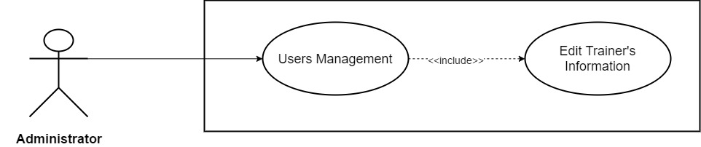

*Figure 3.54: Edit Trainer’s Information*

|  |  |  |  |  |  |  |
| --- | --- | --- | --- | --- | --- | --- |
| **Use Case ID** | UC43 | | | | **Version** | 1.0 |
| **Use Case Name** | Edit Trainer’s Information | | | | | |
| **Create By** | TruongTN | | | | **Last Updated** |  |
| **Primary Actor** | Administrator | | | | **Secondary Actor** |  |
| **Description** | Edit Trainer’s Information | | | | | |
| **Pre-Conditions** |  | | | | | |
| **Post-Conditions** |  | | | | | |
| **Normal Flows** | | | | | | |
| **Step** | **Actor** | | | **Action** | | |
| 1 | Administrator | | | Click “Go to Dashboard” in the menu. | | |
| 2 | System | | | Send Admin to Admin’s Dashboard. | | |
| 3 | Administrator | | | Click “Users”. | | |
| 4 | System | | | Drop down list include “Learners” and “Trainers” | | |
| 5 | Administrator | | | Click “Trainers” | | |
| 6 | System | | | Display trainers management page. | | |
| 7 | Administrator | | | Click “Edit” next to trainer’s name that needed to be edit. | | |
| 8 | Administrator | | | Fill in all information that Administrator want to edit. | | |
| 9 | Administrator | | | Click “Save” to save new information and “Cancel” to cancel. | | |
| 10 | System | | | Save new information account into system | | |
|  |  | | |  | | |
| **Exception** | | | | | | |
| **EC1** | | At step 8, Administrator remove all required field and leave it blank. | | | | |
| **Step** | | **Actor** | **Action** | | | |
| 8.1 | | Administrator | Remove and leave all required field blank. | | | |
| 8.2 | | Administrator | Click “Save” button. | | | |
| 8.3 | | System | Display message: “Please Fill In All Required Field!” | | | |
| **EC2** | | At step 8, Administrator only remove Trainer Name and leave it blank. | | | | |
| **Step** | | **Actor** | **Action** | | | |
| 8.1 | | Administrator | Remove and leave Trainer Name blank. | | | |
| 8.2 | | Administrator | Click “Save” button. | | | |
| 8.3 | | System | Display message: “Please Enter Trainer Name!” | | | |
| **EC3** | | At step 8, only *Fields* is not selected. | | | | |
| **Step** | | **Actor** | **Action** | | | |
| 8.1 | | Administrator | Do not select *Fields.* | | | |
| 8.2 | | Administrator | Click “Save” button. | | | |
| 8.3 | | System | Display message: “Please Select Fields!” | | | |
| **EC4** | | At step 8, Administrator remove and leave *Contact* blank. | | | | |
| **Step** | | **Actor** | **Action** | | | |
| 8.1 | | Administrator | Remove and leave *Contact* field blank. | | | |
| 8.2 | | Administrator | Click “Save” button. | | | |
| 8.3 | | System | Display message: “Please Enter Password!” | | | |
| **EC5** | | At step 8, Administrator only remove and leave *Address* blank. | | | | |
| **Step** | | **Actor** | **Action** | | | |
| 8.1 | | Administrator | Remove and leave *Address* blank. | | | |
| 8.2 | | Administrator | Click “Save” button. | | | |
| 8.3 | | System | Display message: “Please Enter Address!” | | | |
| **EC6** | | At step 8, *Introduction*’s length > 200 character. | | | | |
| **Step** | | **Actor** | **Action** | | | |
| 8.1 | | Administrator | Enter more than 200 character in *Introduction* field. | | | |
| 8.2 | | Administrator | Click “Save” button. | | | |
| 8.3 | | System | Display message: “Length must be < 200” | | | |
|  | | | | | | |
|  | | | | | | |
| **Priority** | High | | | | | |
| **Frequency of Use** | High | | | | | |
| **Business Rules** |  | | | | | |

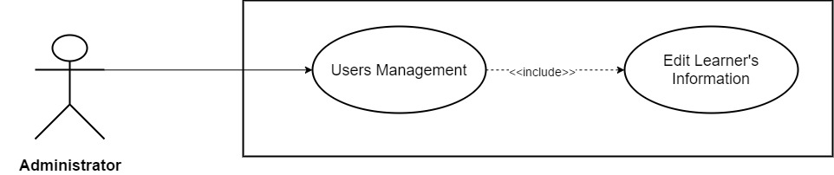

*Figure 3.55: Edit Learner’s Information*

|  |  |  |  |  |  |  |
| --- | --- | --- | --- | --- | --- | --- |
| **Use Case ID** | UC44 | | | | **Version** | 1.0 |
| **Use Case Name** | Edit Learner’s Information | | | | | |
| **Create By** | TruongTN | | | | **Last Updated** |  |
| **Primary Actor** | Administrator | | | | **Secondary Actor** |  |
| **Description** | Edit Learner’s Information | | | | | |
| **Pre-Conditions** |  | | | | | |
| **Post-Conditions** |  | | | | | |
| **Normal Flows** | | | | | | |
| **Step** | **Actor** | | | **Action** | | |
| 1 | Administrator | | | Click “Go to Dashboard” in the menu. | | |
| 2 | System | | | Send Admin to Admin’s Dashboard. | | |
| 3 | Administrator | | | Click “Users”. | | |
| 4 | System | | | Drop down list include “Learners” and “Trainers” | | |
| 5 | Administrator | | | Click “Learners” | | |
| 6 | System | | | Display learners management page. | | |
| 7 | Administrator | | | Click “Edit” next to learner’s name that needed to be edit. | | |
| 8 | Administrator | | | Fill in all information that Administrator want to edit. | | |
| 9 | Administrator | | | Click “Save” to save new information and “Cancel” to cancel. | | |
| 10 | System | | | Save new information account into system | | |
|  |  | | |  | | |
| **Exception** | | | | | | |
| **EC1** | | At step 8, Administrator remove all required field and leave it blank. | | | | |
| **Step** | | **Actor** | **Action** | | | |
| 8.1 | | Administrator | Remove and leave all required field blank. | | | |
| 8.2 | | Administrator | Click “Save” button. | | | |
| 8.3 | | System | Display message: “Please Fill In All Required Field!” | | | |
| **EC2** | | At step 8, Administrator only remove First Name and leave it blank. | | | | |
| **Step** | | **Actor** | **Action** | | | |
| 8.1 | | Administrator | Remove and leave First Name blank. | | | |
| 8.2 | | Administrator | Click “Save” button. | | | |
| 8.3 | | System | Display message: “Please Enter First Name!” | | | |
| **EC3** | | At step 8, Administrator only remove Last Name and leave it blank. | | | | |
| **Step** | | **Actor** | **Action** | | | |
| 8.1 | | Administrator | Remove and leave Last Name blank. | | | |
| 8.2 | | Administrator | Click “Save” button. | | | |
| 8.3 | | System | Display message: “Please Enter Last Name!” | | | |
| **EC4** | | At step 8, Administrator leave Date of Birth blank. | | | | |
| **Step** | | **Actor** | **Action** | | | |
| 8.1 | | Administrator | Leave Date of Birth blank. | | | |
| 8.2 | | Administrator | Click “Save” button. | | | |
| 8.3 | | System | Display message: “Please Enter Date of Birth!” | | | |
| **EC5** | | At step 8, Administrator remove and leave *Contact* blank. | | | | |
| **Step** | | **Actor** | **Action** | | | |
| 8.1 | | Administrator | Remove and leave *Contact* field blank. | | | |
| 8.2 | | Administrator | Click “Save” button. | | | |
| 8.3 | | System | Display message: “Please Enter Password!” | | | |
| **EC6** | | At step 8, Administrator only remove and leave *Job* blank. | | | | |
| **Step** | | **Actor** | **Action** | | | |
| 8.1 | | Administrator | Remove and leave *Job* blank. | | | |
| 8.2 | | Administrator | Click “Save” button. | | | |
| 8.3 | | System | Display message: “Please Enter Job!” | | | |
| **EC7** | | At step 8, *Introduction*’s length > 200 character. | | | | |
| **Step** | | **Actor** | **Action** | | | |
| 8.1 | | Administrator | Enter more than 200 character in *Introduction* field. | | | |
| 8.2 | | Administrator | Click “Save” button. | | | |
| 8.3 | | System | Display message: “Length must be < 200” | | | |
|  | | | | | | |
|  | | | | | | |
| **Priority** | High | | | | | |
| **Frequency of Use** | High | | | | | |
| **Business Rules** |  | | | | | |

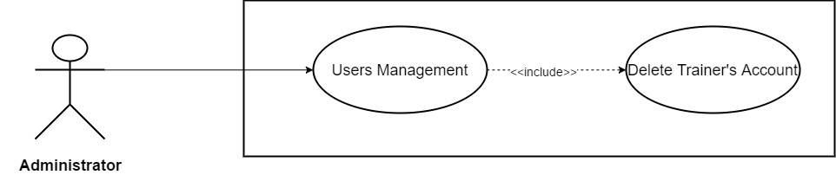

*Figure 3.56: Delete Trainer’s Account*

|  |  |  |  |  |
| --- | --- | --- | --- | --- |
| **Use Case ID** | UC45 | | **Version** | 1.0 |
| **Use Case Name** | Delete Trainer’s Account | | | |
| **Create By** | TruongTN | | **Last Updated** |  |
| **Primary Actor** | Administrator | | **Secondary Actor** |  |
| **Description** | Delete Trainer’s Account | | | |
| **Pre-Conditions** |  | | | |
| **Post-Conditions** |  | | | |
| **Normal Flows** | | | | |
| **Step** | **Actor** | **Action** | | |
| 1 | Administrator | Click “Go to Dashboard” in the menu. | | |
| 2 | System | Send Admin to Admin’s Dashboard. | | |
| 3 | Administrator | Click “Users”. | | |
| 4 | System | Drop down list include “Learners” and “Trainers” | | |
| 5 | Administrator | Click “Trainers” | | |
| 6 | System | Display trainers management page. | | |
| 7 | Administrator | Click “Delete” next to trainer’s name that needed to be edit. | | |
| 8 | System | Display dialog box “Do you want to delete this user?” “Yes” “No” | | |
| 9 | Administrator | Click “Yes” to delete or “No” to cancel. | | |
| 10 | System | Delete account from system. | | |
|  |  |  | | |
|  | | | | |
|  | | | | |
| **Priority** | High | | | |
| **Frequency of Use** | High | | | |
| **Business Rules** |  | | | |

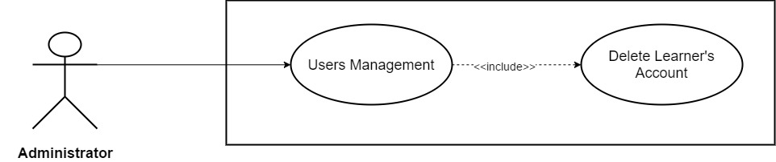

*Figure 3.57: Delete Learner’s Account*

|  |  |  |  |  |
| --- | --- | --- | --- | --- |
| **Use Case ID** | UC46 | | **Version** | 1.0 |
| **Use Case Name** | Delete Learner’s Account | | | |
| **Create By** | TruongTN | | **Last Updated** |  |
| **Primary Actor** | Administrator | | **Secondary Actor** |  |
| **Description** | Delete Learner’s Account | | | |
| **Pre-Conditions** |  | | | |
| **Post-Conditions** |  | | | |
| **Normal Flows** | | | | |
| **Step** | **Actor** | **Action** | | |
| 1 | Administrator | Click “Go to Dashboard” in the menu. | | |
| 2 | System | Send Admin to Admin’s Dashboard. | | |
| 3 | Administrator | Click “Users”. | | |
| 4 | System | Drop down list include “Learners” and “Trainers” | | |
| 5 | Administrator | Click “Learners” | | |
| 6 | System | Display learner management page. | | |
| 7 | Administrator | Click “Delete” next to learner’s name that needed to be edit. | | |
| 8 | System | Display dialog box “Do you want to delete this user?” “Yes” “No” | | |
| 9 | Administrator | Click “Yes” to delete or “No” to cancel. | | |
| 10 | System | Delete account from system. | | |
|  |  |  | | |
|  | | | | |
|  | | | | |
| **Priority** | High | | | |
| **Frequency of Use** | High | | | |
| **Business Rules** |  | | | |

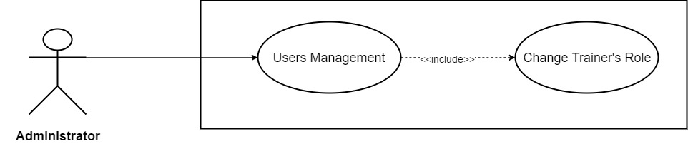

*Figure 3.58: Change Trainer’s Role*

|  |  |  |  |  |
| --- | --- | --- | --- | --- |
| **Use Case ID** | UC47 | | **Version** | 1.0 |
| **Use Case Name** | Change Trainer’s Role | | | |
| **Create By** | TruongTN | | **Last Updated** |  |
| **Primary Actor** | Administrator | | **Secondary Actor** |  |
| **Description** | Change Trainer’s Role | | | |
| **Pre-Conditions** |  | | | |
| **Post-Conditions** |  | | | |
| **Normal Flows** | | | | |
| **Step** | **Actor** | **Action** | | |
| 1 | Administrator | Click “Go to Dashboard” in the menu. | | |
| 2 | System | Send Admin to Admin’s Dashboard. | | |
| 3 | Administrator | Click “Users”. | | |
| 4 | System | Drop down list include “Learners” and “Trainers” | | |
| 5 | Administrator | Click “Trainers” | | |
| 6 | System | Display trainers management page. | | |
| 7 | Administrator | In “Trainers List” table – “Role” column, click “Admin” to change trainer role to admin or click “Learner” to change their role to learner. | | |
| 8 | System | Display dialog box “Do you want to change this user role?” “Yes” “No” | | |
| 9 | Administrator | Click “Yes” to change or “No” to cancel. | | |
| 10 | System | Change trainer role, update new role into system. | | |
|  |  |  | | |
|  | | | | |
|  | | | | |
| **Priority** | High | | | |
| **Frequency of Use** | High | | | |
| **Business Rules** |  | | | |

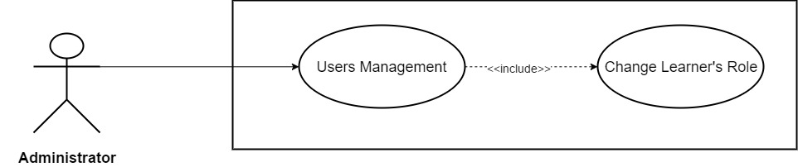

*Figure 3.59: Change Learner’s Role*

|  |  |  |  |  |
| --- | --- | --- | --- | --- |
| **Use Case ID** | UC48 | | **Version** | 1.0 |
| **Use Case Name** | Change Learner’s Role | | | |
| **Create By** | TruongTN | | **Last Updated** |  |
| **Primary Actor** | Administrator | | **Secondary Actor** |  |
| **Description** | Change Learner’s Role | | | |
| **Pre-Conditions** |  | | | |
| **Post-Conditions** |  | | | |
| **Normal Flows** | | | | |
| **Step** | **Actor** | **Action** | | |
| 1 | Administrator | Click “Go to Dashboard” in the menu. | | |
| 2 | System | Send Admin to Admin’s Dashboard. | | |
| 3 | Administrator | Click “Users”. | | |
| 4 | System | Drop down list include “Learners” and “Trainers” | | |
| 5 | Administrator | Click “Learners” | | |
| 6 | System | Display learners management page. | | |
| 7 | Administrator | In “Learners List” table – “Role” column, click “Admin” to change trainer role to admin or click “Trainer” to change their role to trainer. | | |
| 8 | System | Display dialog box “Do you want to change this user role?” “Yes” “No” | | |
| 9 | Administrator | Click “Yes” to change or “No” to cancel. | | |
| 10 | System | Change trainer role, update new role into system. | | |
|  |  |  | | |
|  | | | | |
|  | | | | |
| **Priority** | High | | | |
| **Frequency of Use** | High | | | |
| **Business Rules** |  | | | |

* + 1. **Administrator/Learner**

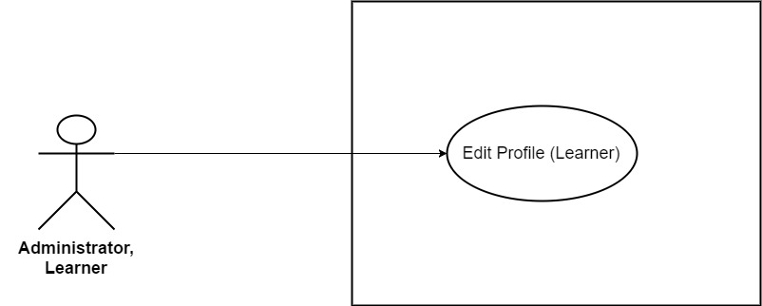

*Figure 3.60: Edit Profile (Learner)*

|  |  |  |  |  |
| --- | --- | --- | --- | --- |
| **Use Case ID** | UC49 | | **Version** | 1.0 |
| **Use Case Name** | Edit Profile (*Learner*) | | | |
| **Create By** | TruongTN | | **Last Updated** |  |
| **Primary Actor** | Learner | | **Secondary Actor** | Administrator |
| **Description** | Edit account’s information for *Learner.* | | | |
| **Pre-Conditions** | * User must login first. * Internet connection is required. | | | |
| **Post-Conditions** | * New account information is saved and updated into system. | | | |
| **Normal Flows** | | | | |
| **Step** | **Actor** | **Action** | | |
| 1 | Learner | Move mouse to Learner’s name to the right of search bar. | | |
| 2 | System | Display drop-down list. | | |
| 3 | Learner | Click “My Profile” | | |
| 4 | System | Send Trainer to “My Profile” page | | |
| 5 | System | Display “My Profile” page which contain the following information:   * Email * First Name * Last Name * Gender * Date of Birth * Contact * Job * Introduction | | |
| 6 | Learner | Enter all the information that they wish to edit. Email can’t be edit. Gender can’t be blank. | | |
| 7 | Learner | Click “Save” button. | | |
| 8 | System | Update information into system’s Database. | | |
| 9 | System | Display “My Profile” page with updated information. | | |
|  | | | | |
| **Exception** | | | | |
| **EC1** | At step 6, Learner remove all required field and leave it blank. | | | |
| **Step** | **Actor** | **Action** | | |
| 6.1 | Learner | Remove and leave all required field blank. | | |
| 6.2 | Learner | Click “Save” button. | | |
| 6.3 | System | Display message: “Please Fill In All Required Field!” | | |
| **EC2** | At step 6, Learner only remove First Name and leave it blank. | | | |
| **Step** | **Actor** | **Action** | | |
| 6.1 | Learner | Remove and leave First Name blank. | | |
| 6.2 | Learner | Click “Save” button. | | |
| 6.3 | System | Display message: “Please Enter First Name!” | | |
| **EC3** | At step 6, Learner only remove Last Name and leave it blank. | | | |
| **Step** | **Actor** | **Action** | | |
| 6.1 | Learner | Remove and leave Last Name blank. | | |
| 6.2 | Learner | Click “Save” button. | | |
| 6.3 | System | Display message: “Please Enter Last Name!” | | |
| **EC4** | At step 6, Learner leave Date of Birth blank. | | | |
| **Step** | **Actor** | **Action** | | |
| 6.1 | Learner | Leave Date of Birth blank. | | |
| 6.2 | Learner | Click “Save” button. | | |
| 6.3 | System | Display message: “Please Enter Date of Birth!” | | |
| **EC5** | At step 6, Learner remove and leave *Contact* blank. | | | |
| **Step** | **Actor** | **Action** | | |
| 6.1 | Learner | Remove and leave *Contact* field blank. | | |
| 6.2 | Learner | Click “Save” button. | | |
| 6.3 | System | Display message: “Please Enter Password!” | | |
| **EC6** | At step 6, Learner only remove and leave *Job* blank. | | | |
| **Step** | **Actor** | **Action** | | |
| 6.1 | Learner | Remove and leave *Job* blank. | | |
| 6.2 | Learner | Click “Save” button. | | |
| 6.3 | System | Display message: “Please Enter Job!” | | |
| **EC7** | At step 6, *Introduction*’s length > 200 character. | | | |
| **Step** | **Actor** | **Action** | | |
| 6.1 | Learner | Enter more than 200 character in *Introduction* field. | | |
| 6.2 | Learner | Click “Save” button. | | |
| 6.3 | System | Display message: “Length must be < 200” | | |
|  |  |  | | |
| **Priority** | High | | | |
| **Frequency of Use** | High | | | |
| **Business Rules** | BR1 | | | |

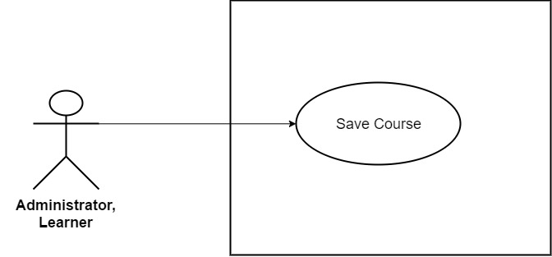

*Figure 3.61: Save Course*

|  |  |  |  |  |
| --- | --- | --- | --- | --- |
| **Use Case ID** | UC50 | | **Version** | 1.0 |
| **Use Case Name** | Save Course | | | |
| **Create By** | TruongTN | | **Last Updated** |  |
| **Primary Actor** | Learner | | **Secondary Actor** | Administrator |
| **Description** | Save course. | | | |
| **Pre-Conditions** | * User must login first. * Internet connection is required. * User must be Learner or Administrator. | | | |
| **Post-Conditions** | * Selected course is saved. | | | |
| **Normal Flows** | | | | |
| **Step** | **Actor** | **Action** | | |
| 1 | Learner | Click the flag in the top-left corner of course image. | | |
| 2 | System | Display message: “Course Saved!” | | |
| **Exception** | | | | |
| **EC1** | At step 1, Learner click save course that has already been saved. | | | |
| 1.1 | Learner | Click save course that has already been saved. | | |
| 1.2 | System | Display message: “Course Unsaved!” | | |
|  |  |  | | |
|  | | | | |
| **Priority** | High | | | |
| **Frequency of Use** | High | | | |
| **Business Rules** |  | | | |

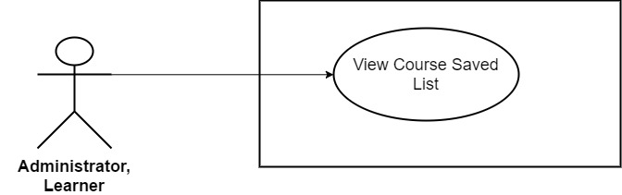

*Figure 3.62: View Course Saved List*

|  |  |  |  |  |
| --- | --- | --- | --- | --- |
| **Use Case ID** | UC51 | | **Version** | 1.0 |
| **Use Case Name** | View Course Saved List | | | |
| **Create By** | TruongTN | | **Last Updated** |  |
| **Primary Actor** | Learner | | **Secondary Actor** | Administrator |
| **Description** | View Course Save List | | | |
| **Pre-Conditions** | * User must login first. * Internet connection is required. * User must be Learner or Administrator. | | | |
| **Post-Conditions** | * Display course saved list. | | | |
| **Normal Flows** | | | | |
| **Step** | **Actor** | **Action** | | |
| 1 | Learner | Move mouse to Learner’s name to the right of search bar. | | |
| 2 | System | Display drop-down list. | | |
| 3 | Learner | Click “Course Saved” | | |
| 4 | System | Display “Course Saved” page . | | |
|  | | | | |
| **Priority** | High | | | |
| **Frequency of Use** | High | | | |
| **Business Rules** |  | | | |

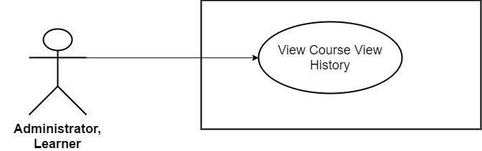

*Figure 3.63: View Course View History*

|  |  |  |  |  |
| --- | --- | --- | --- | --- |
| **Use Case ID** | UC52 | | **Version** | 1.0 |
| **Use Case Name** | View Course View History | | | |
| **Create By** | TruongTN | | **Last Updated** |  |
| **Primary Actor** | Learner | | **Secondary Actor** | Administrator |
| **Description** | View Course View History | | | |
| **Pre-Conditions** | * User must login first. * Internet connection is required. * User must be Learner or Administrator. | | | |
| **Post-Conditions** | * Display course view history. | | | |
| **Normal Flows** | | | | |
| **Step** | **Actor** | **Action** | | |
| 1 | Trainer | Move mouse to Learner’s name to the right of search bar. | | |
| 2 | System | Display drop-down list. | | |
| 3 | Trainer | Click “View’s History” | | |
| 4 | System | Display “View’s History” page . | | |
|  | | | | |
| **Priority** | High | | | |
| **Frequency of Use** | High | | | |
| **Business Rules** |  | | | |

1. **Non-Functional Requirement**
   1. **Usability**

* The website’s UI must be simple, elegant, logical and easy to use.
* Follow Bootstrap framework make design stripped down to the basics, removes any stylistic choices that give it the illusion of three-dimensionality.
* Responsive design, user can easily access by mobile, table and other devices.
  1. **Security**

The security matrix is as follow:

|  |  |  |  |  |
| --- | --- | --- | --- | --- |
| **Functional** | **Guest** | **Learner** | **Trainer** | **Administrator** |
| **Sign Up as Trainer** |  |  |  |  |
| **Sign Up as Learner** |  |  |  |  |
| **Sign In** |  |  |  |  |
| **Log Out** |  |  |  |  |
| **Change Password** |  |  |  |  |
| **Forget Password** |  |  |  |  |
| **Update Profile Picture** |  |  |  |  |
| **View Personal Profile** |  |  |  |  |
| **Send Messages** |  |  |  |  |
| **View Messages** |  |  |  |  |
| **Delete Message** |  |  |  |  |
| **Comment Course** |  |  |  |  |
| **Edit Comment** |  |  |  |  |
| **Delete Comment** |  |  |  |  |
| **Rate Course** |  |  |  |  |
| **Rate Trainer** |  |  |  |  |
| **View Course Statistic** |  |  |  |  |
| **Create New Course** |  |  |  |  |
| **Edit Course Detail** |  |  |  |  |
| **Delete Courses** |  |  |  |  |
| **Upload Documents** |  |  |  |  |
| **Delete Documents** |  |  |  |  |
| **View Documents Dashboard** |  |  |  |  |
| **Edit Profile Trainer** |  |  |  |  |
| **View Course Detail** |  |  |  |  |
| **Search Course** |  |  |  |  |
| **View Trainer List** |  |  |  |  |
| **View Other Public Profile** |  |  |  |  |
| **View Course Comment** |  |  |  |  |
| **View Course’s Rate** |  |  |  |  |
| **View Trainer’s Rate** |  |  |  |  |
| **View Document Picture** |  |  |  |  |
| **View Website Statistic** |  |  |  |  |
| **Review Trainer’s Document** |  |  |  |  |
| **Review New Course** |  |  |  |  |
| **Review Trainer’s Account** |  |  |  |  |
| **Block Learners** |  |  |  |  |
| **Block Trainers** |  |  |  |  |
| **Unblock Learners** |  |  |  |  |
| **Unblock Trainers** |  |  |  |  |
| **Add New Trainer Account** |  |  |  |  |
| **Add New Learner Account** |  |  |  |  |
| **Edit Trainer’s Information** |  |  |  |  |
| **Edit Learner’s Information** |  |  |  |  |
| **Delete Trainer’s Account** |  |  |  |  |
| **Delete Learner’s Account** |  |  |  |  |
| **Change Trainer’s Role** |  |  |  |  |
| **Change Learner’s Role** |  |  |  |  |
| **Edit Profile (Learner)** |  |  |  |  |
| **Save Course** |  |  |  |  |
| **View Course Saved List** |  |  |  |  |
| **View Course View History** |  |  |  |  |